
Samplingsheet Doraintrade 

Subject | 450020556-14-1946
Order | 111
label | 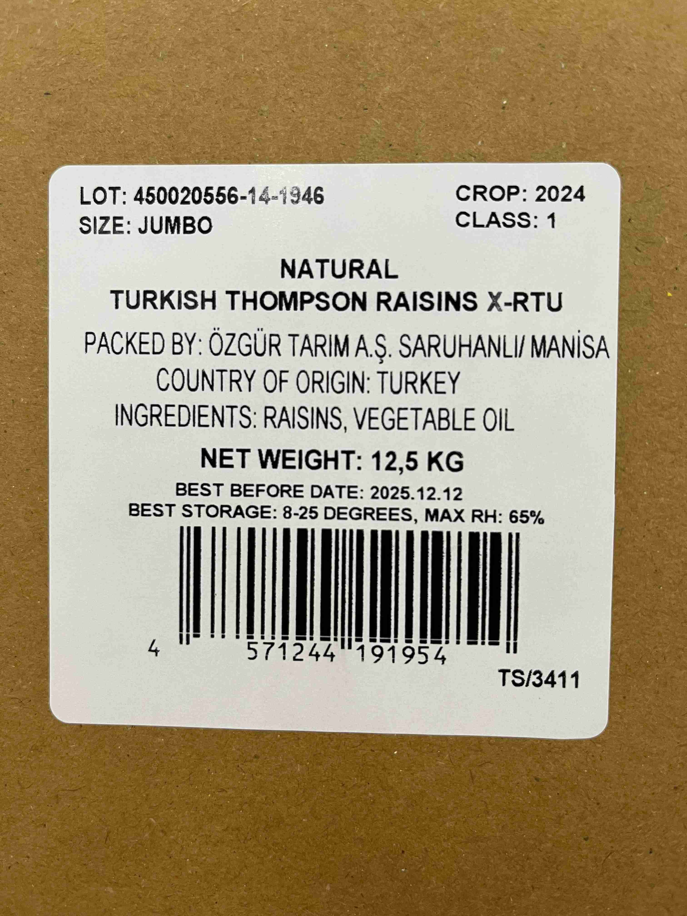
Product Cartons | 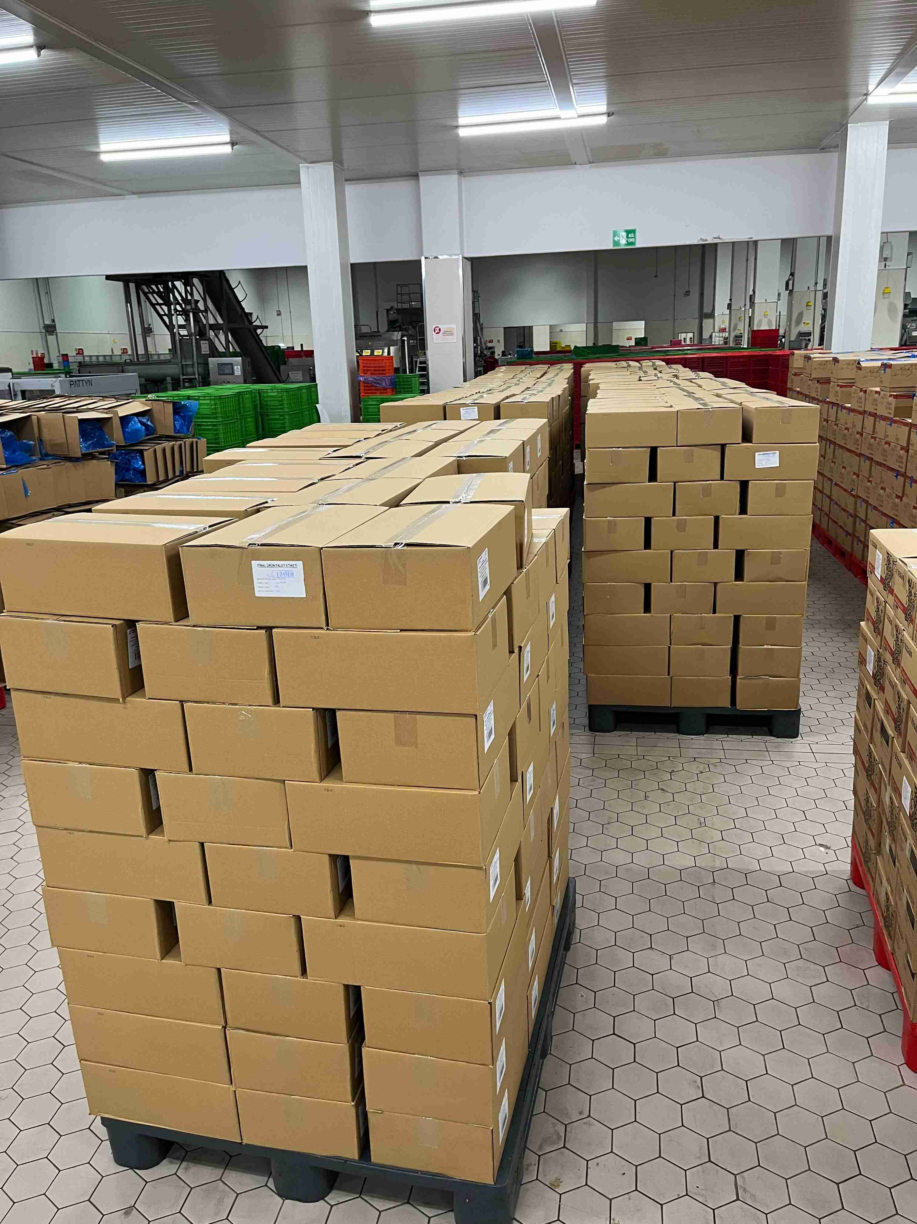
sampling | ${image#3}
sampling | ${image#4}
Sampling | ${image#5}
Sampling Cartons | ${image#6}
mix sample | ${image#7}
Mix Sample | ${image#8}
Product | ${image#9}
Physical Analysis Sample | ${image#10}
Physical analysis sample | ${image#11}
Damaged | ${image#12}
Sugared | ${image#13}
foreign material | ${image#14}
Capstem | ${image#15}
Undeveloped | ${image#16}
Sugary surface (after may) | ${image#17}
Mould | ${image#18}
Shrivelled | ${image#19}
Damage Fruits | ${image#20}

