
Samplingsheet Doraintrade

Subject | 35/35
Order | 35
rotten | 
physical analysis | 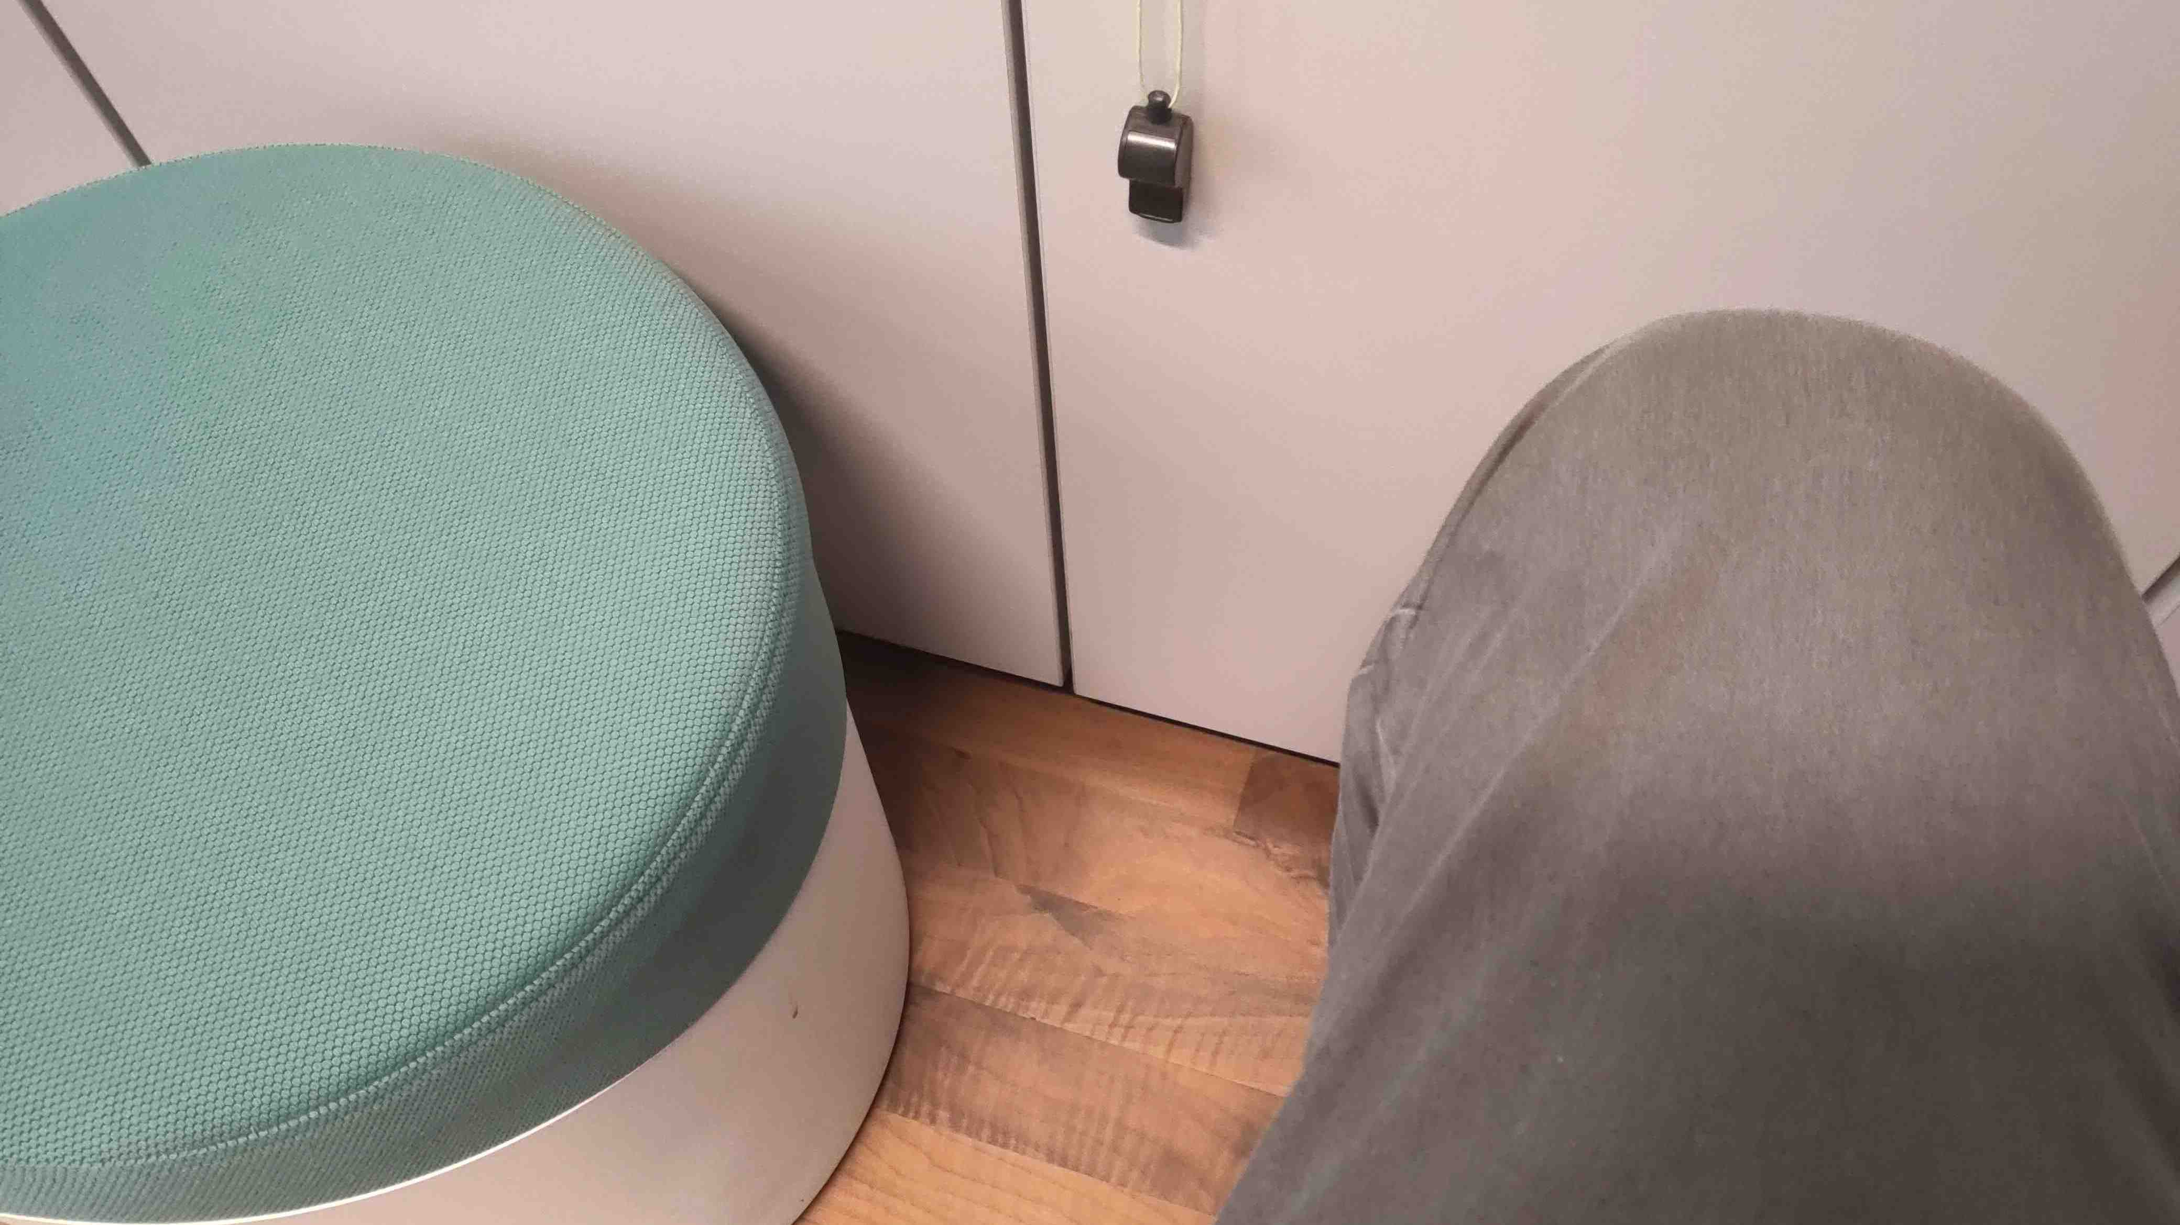
rancid | 

