
Samplingsheet Doraintrade

Subject | 280053788/1-04-0506
Order | 4502067705
label | 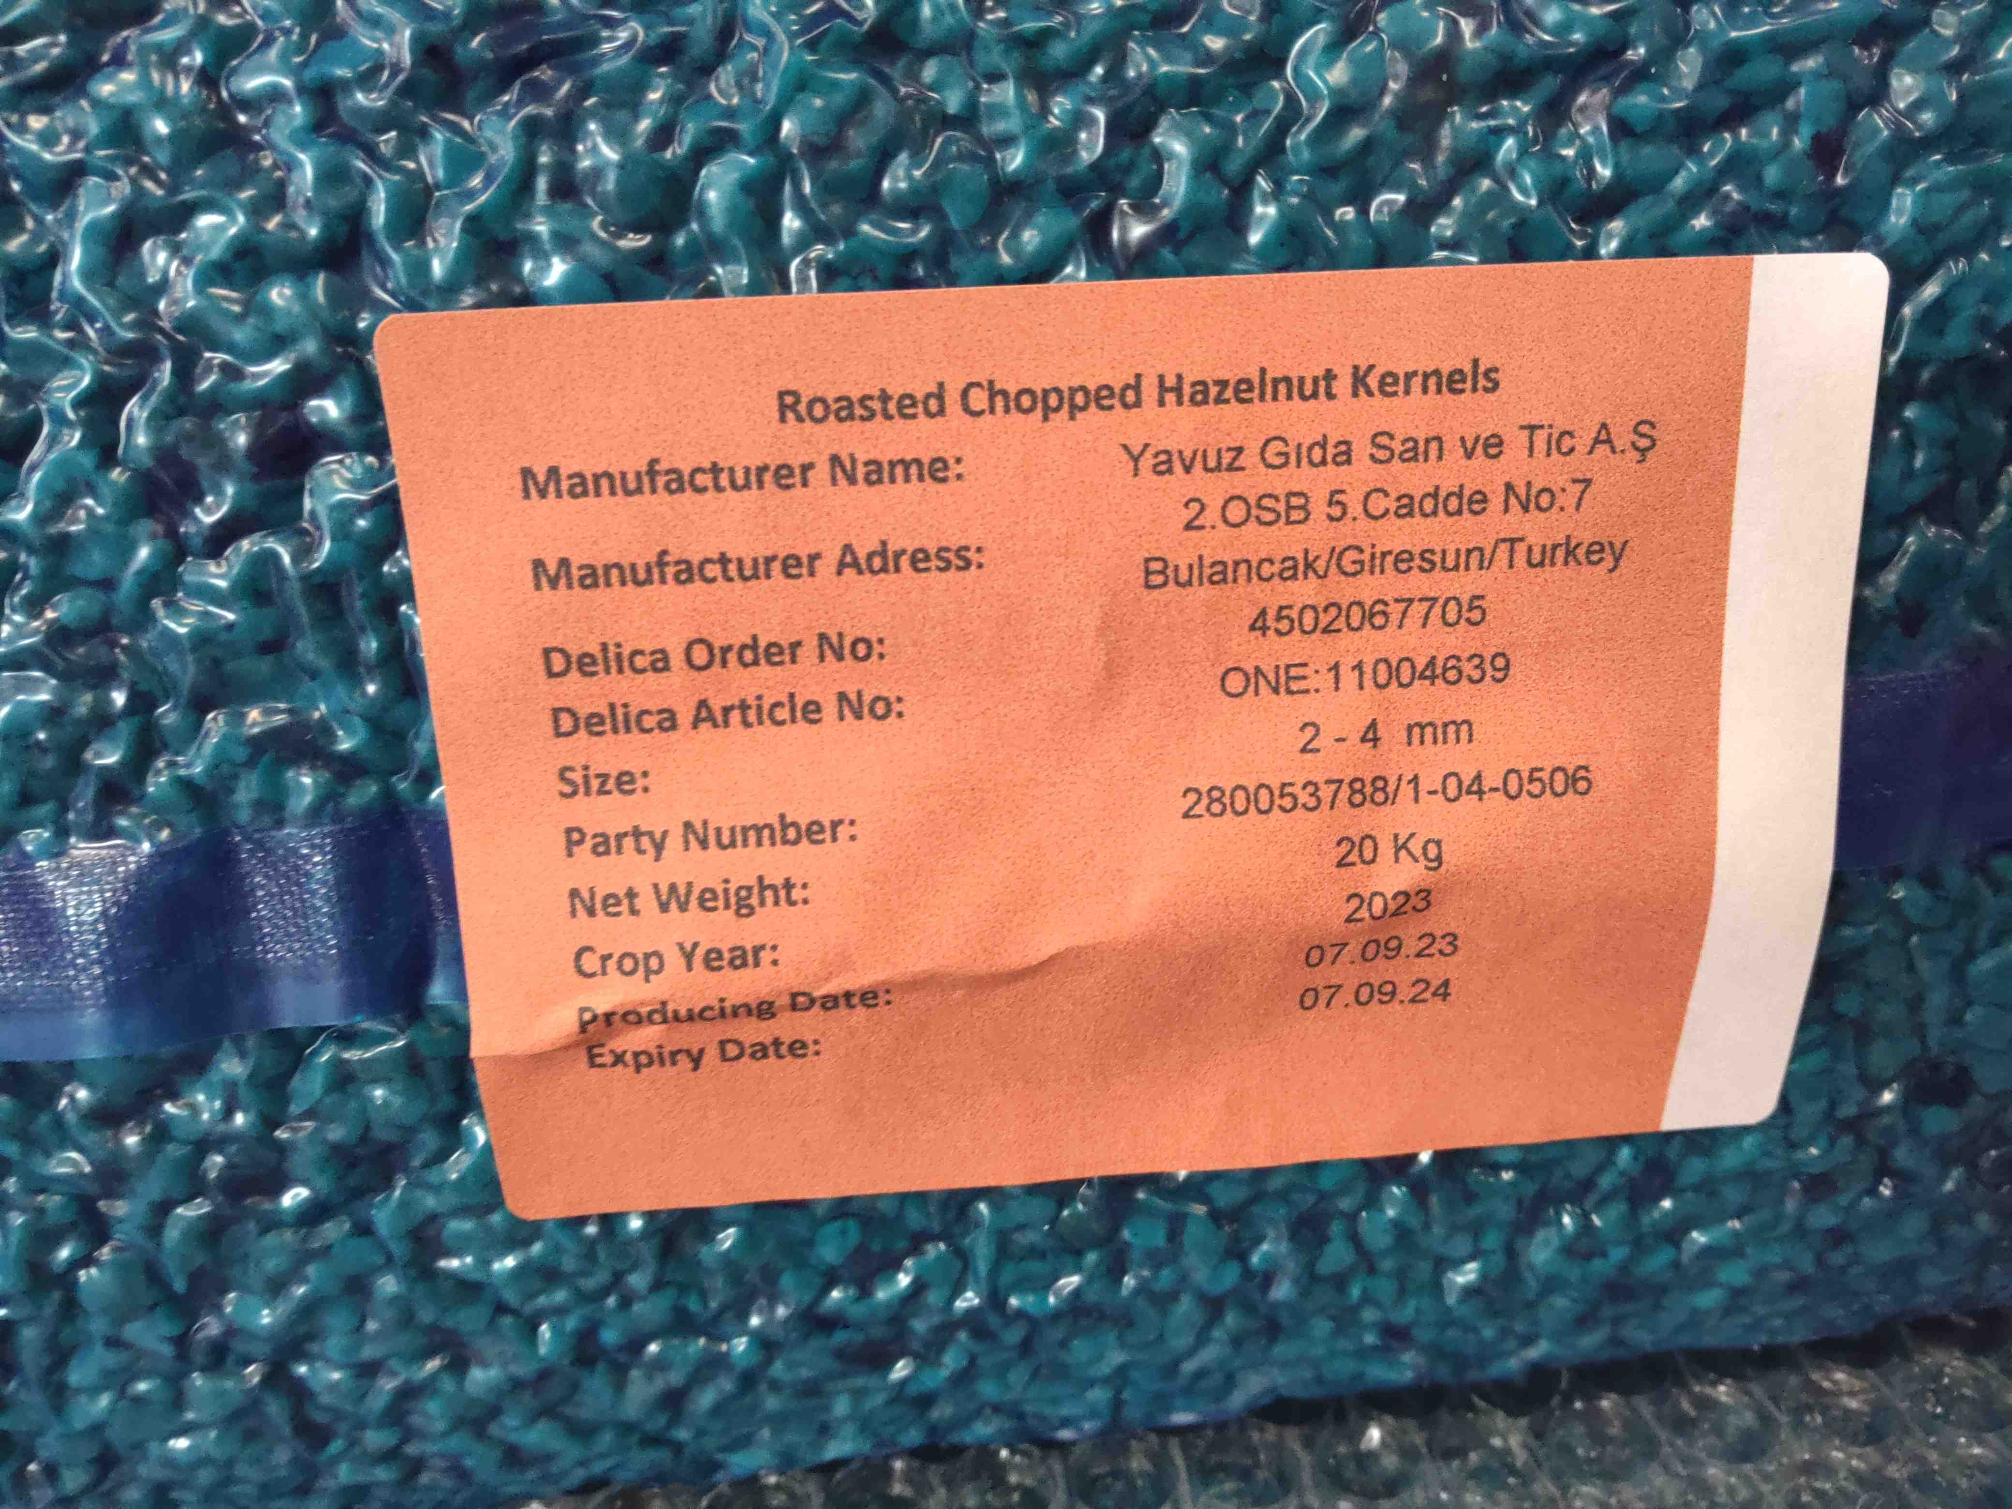
sampling | 