
Samplingsheet Doraintrade 

Subject | 280053788-1-04-2351
Order | 4502720796
label | 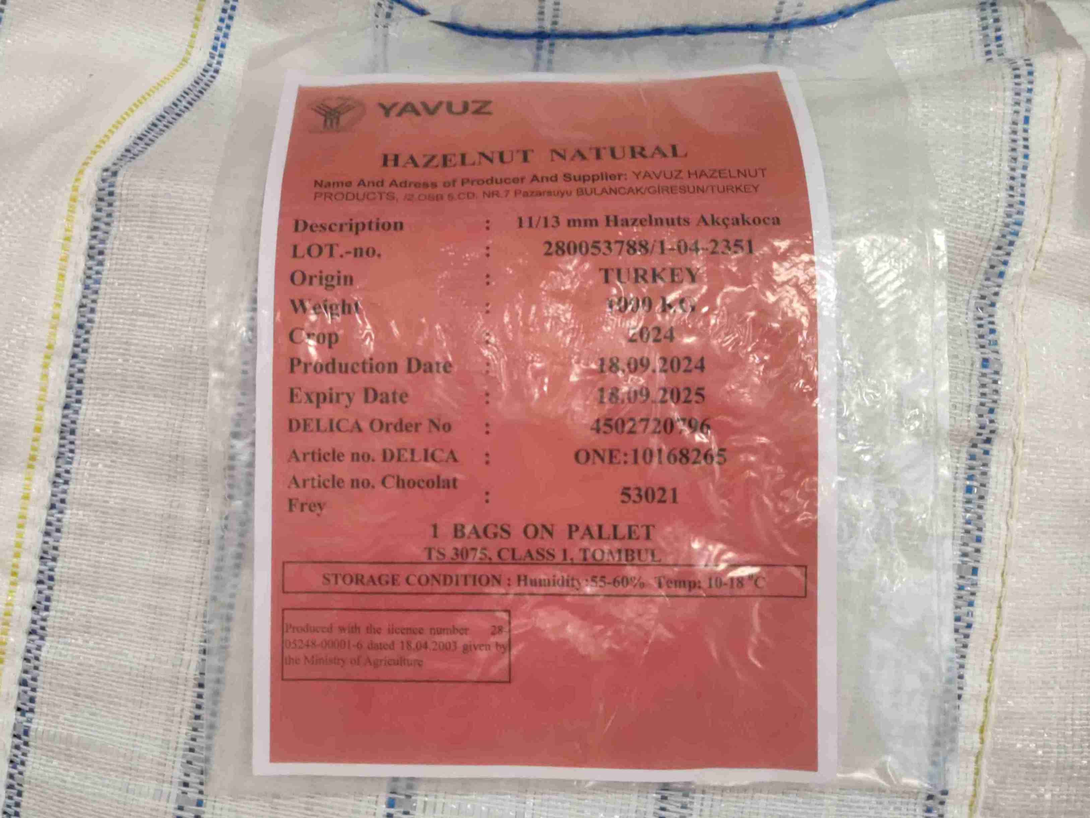
product bigbags | 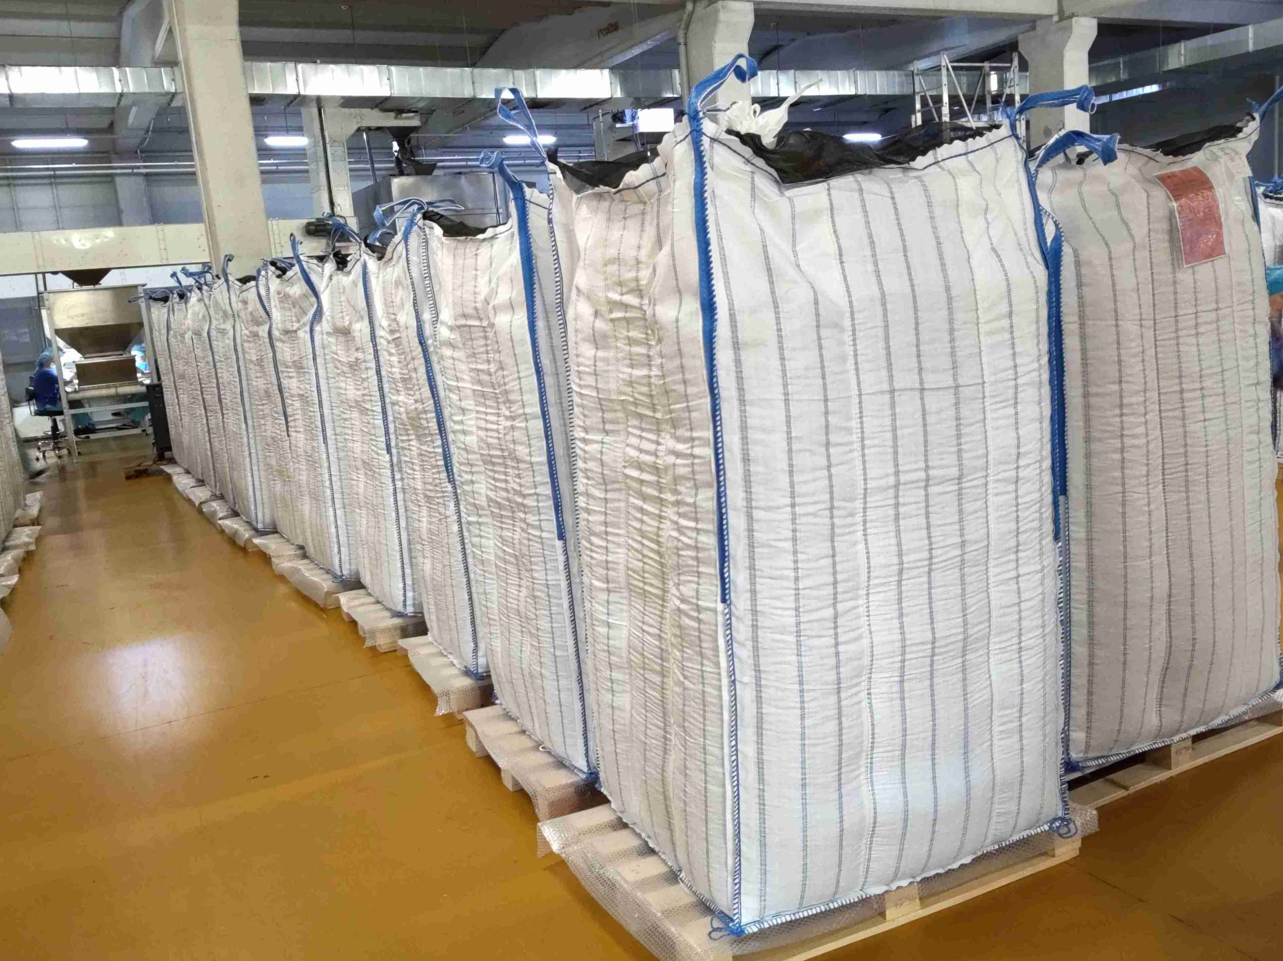
sampling | 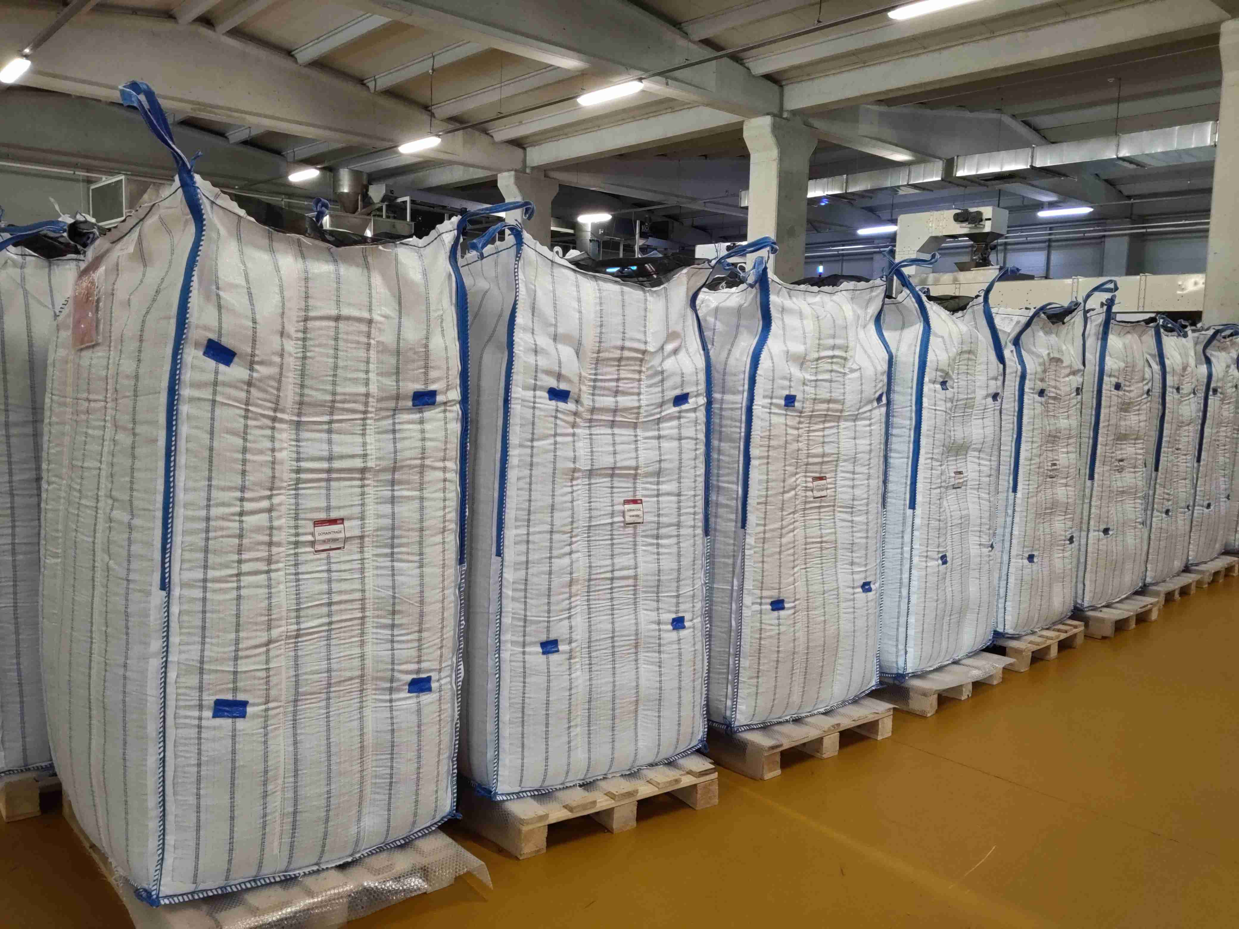
mix sample | 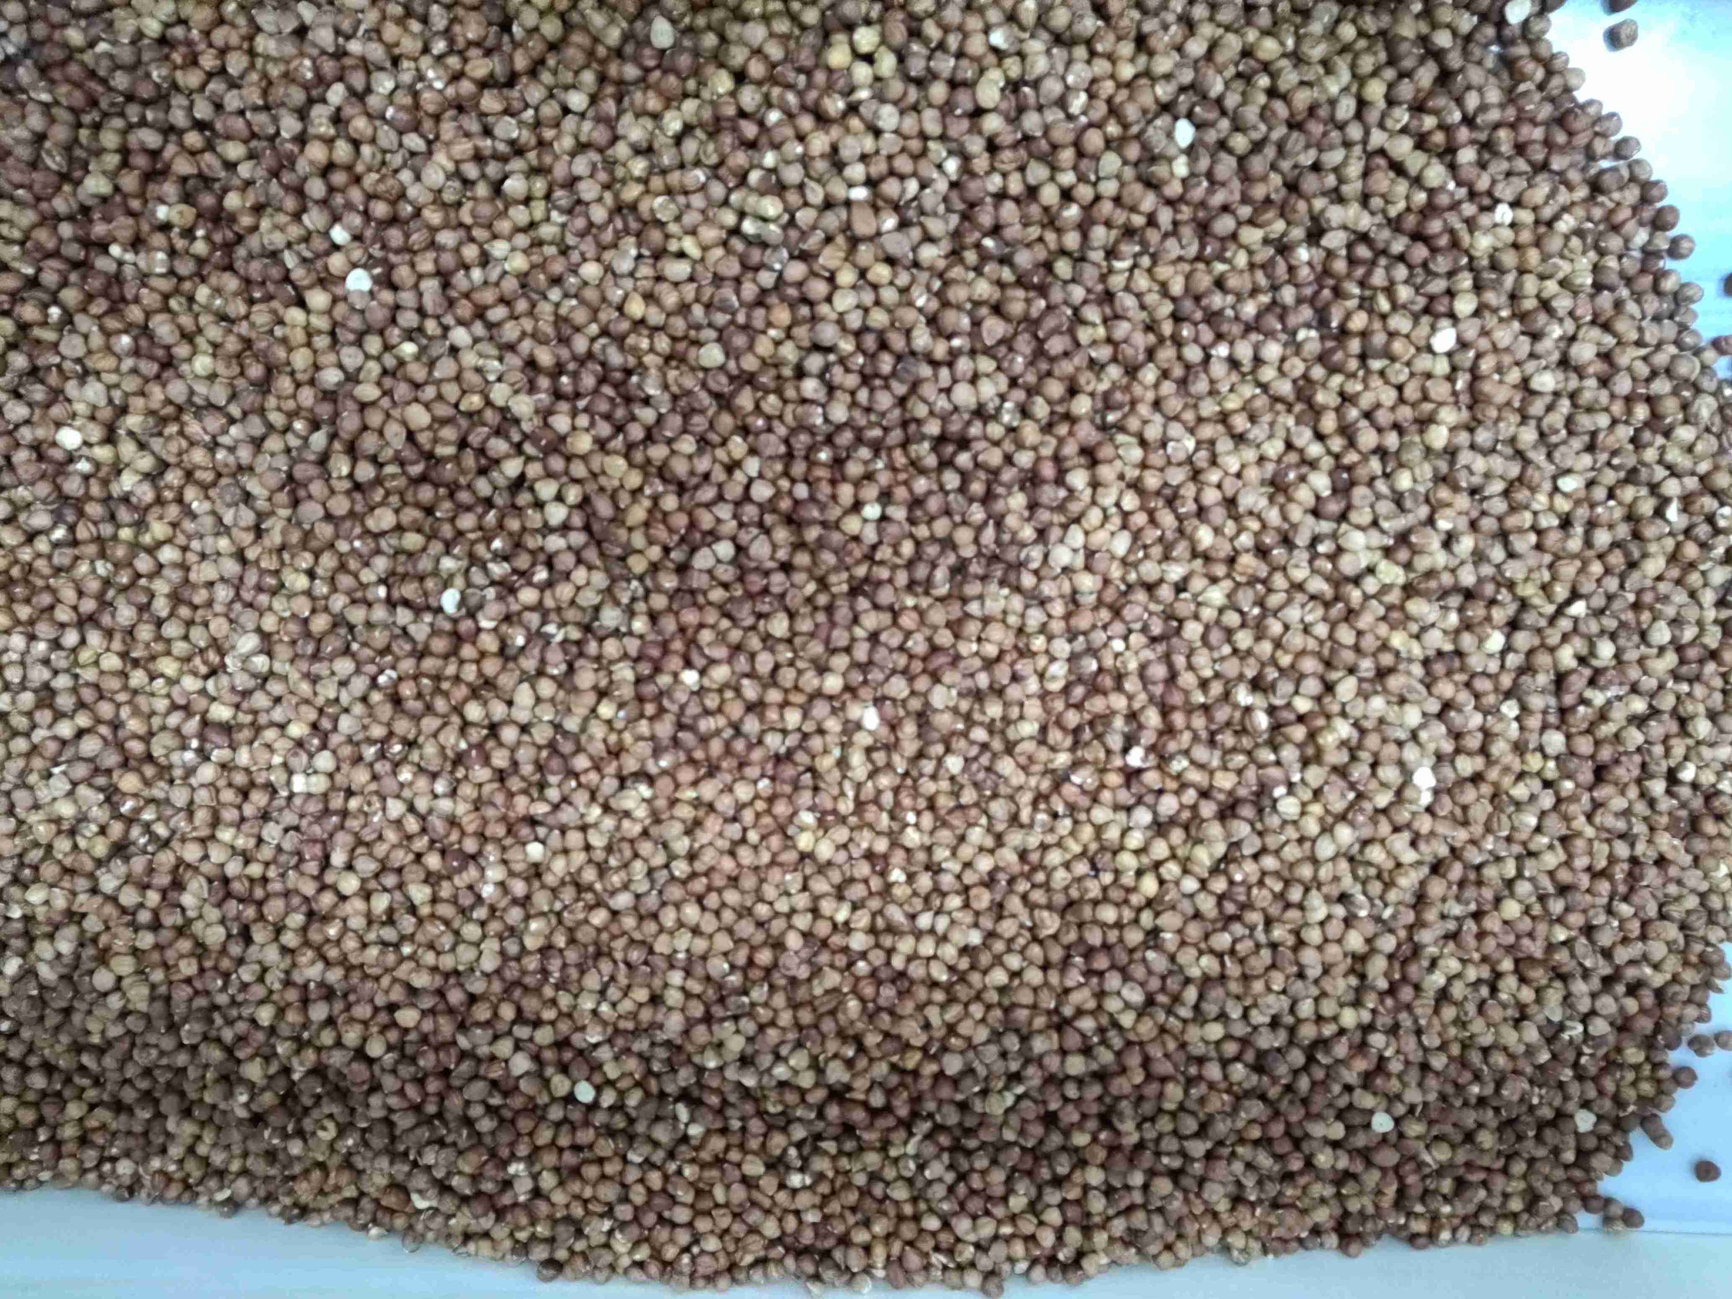
caliber control | 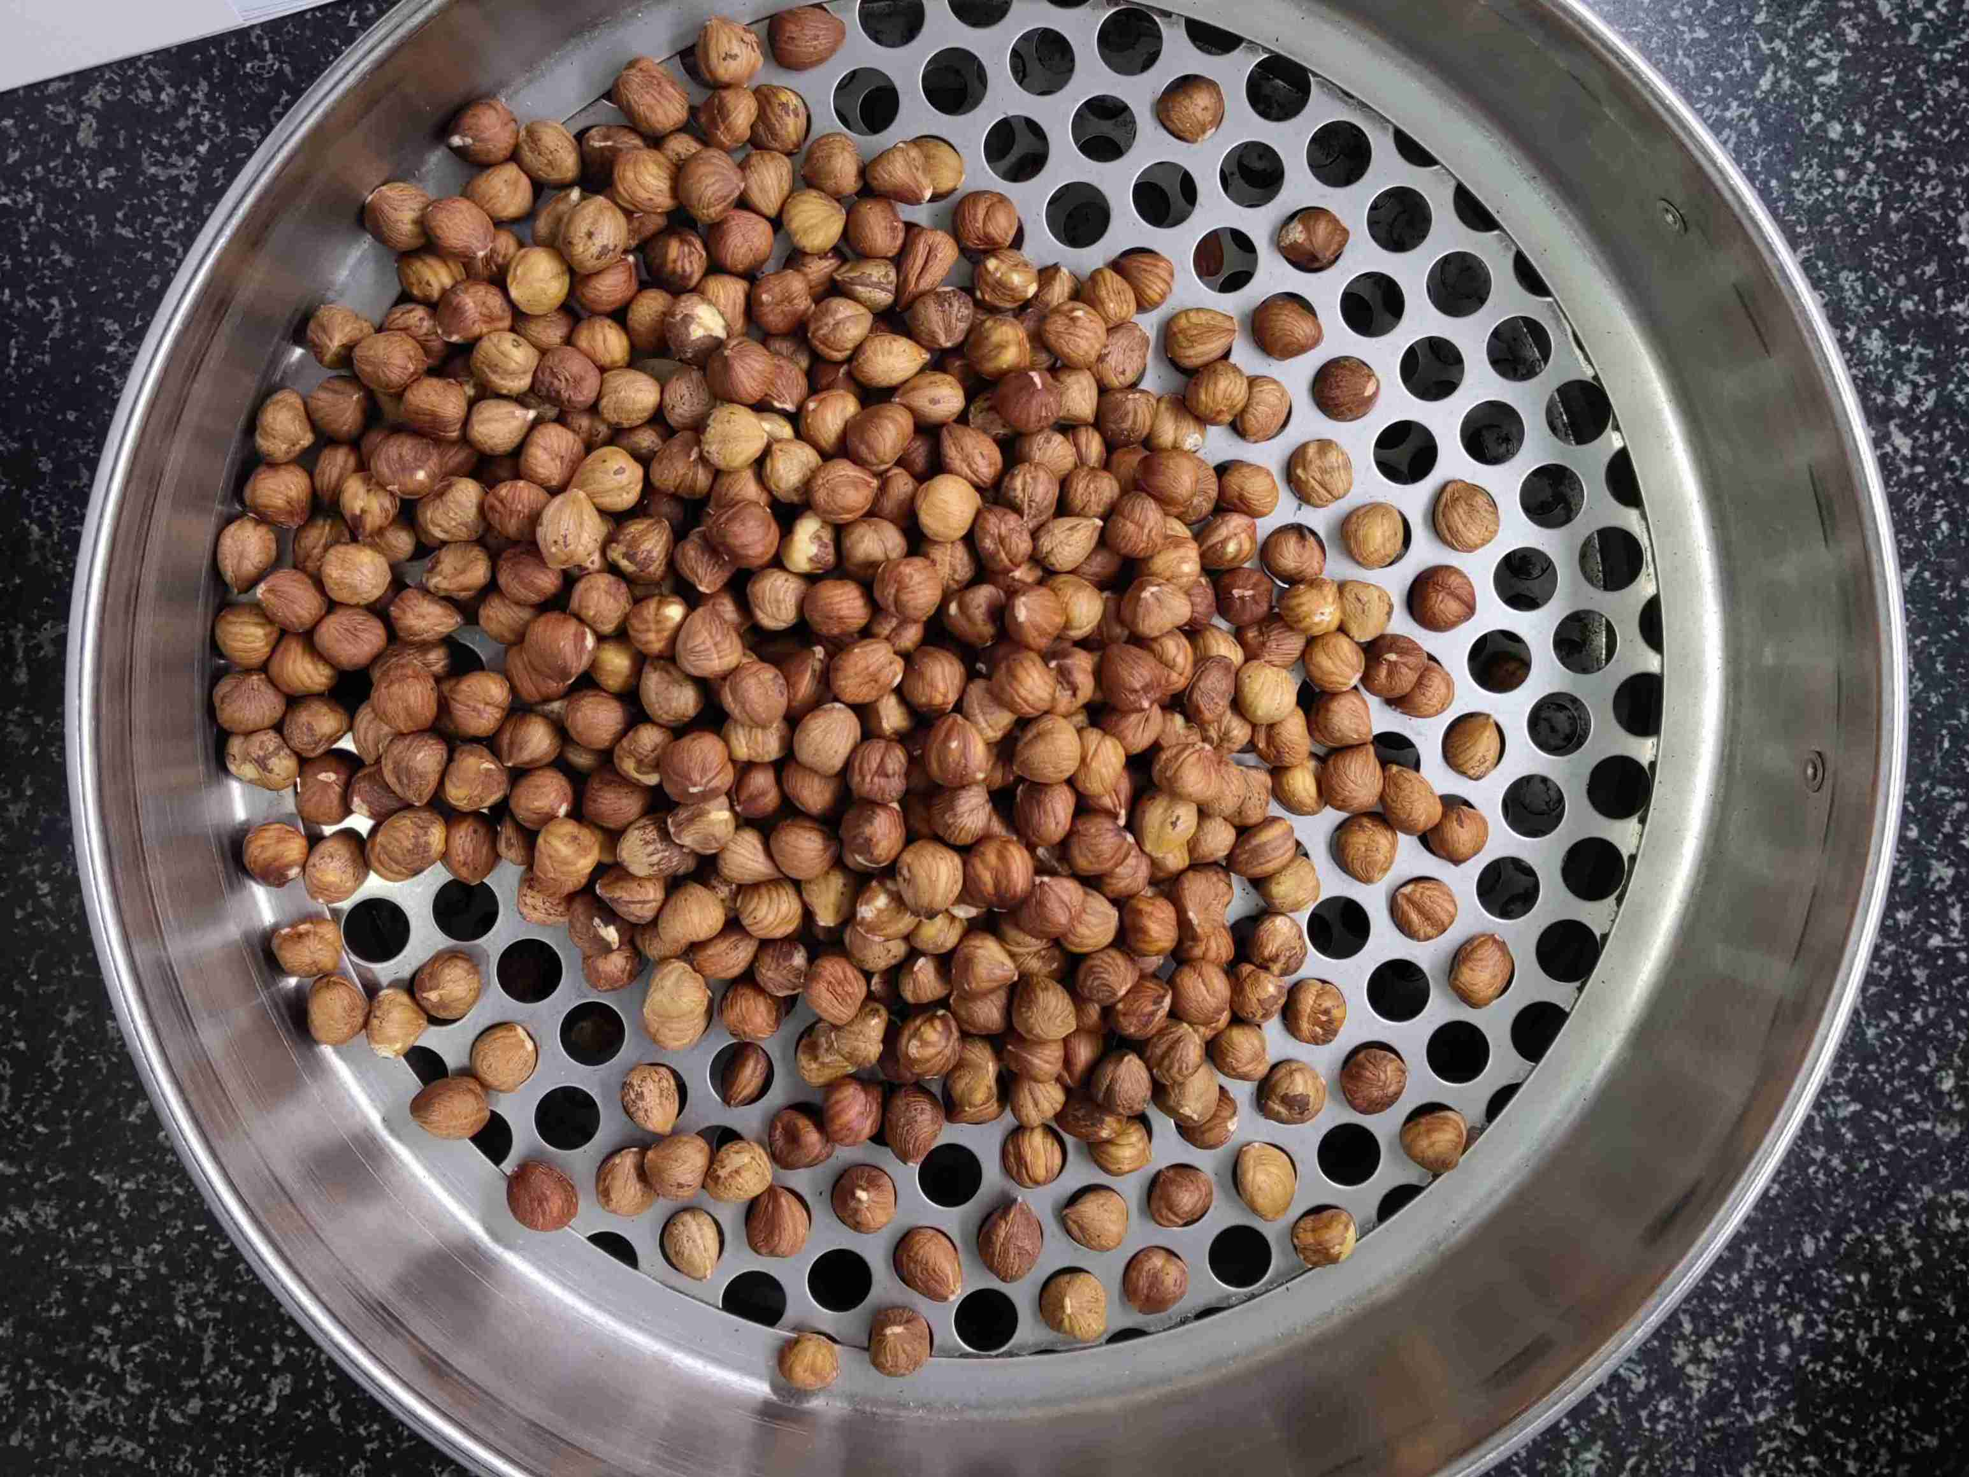
physical analysis | 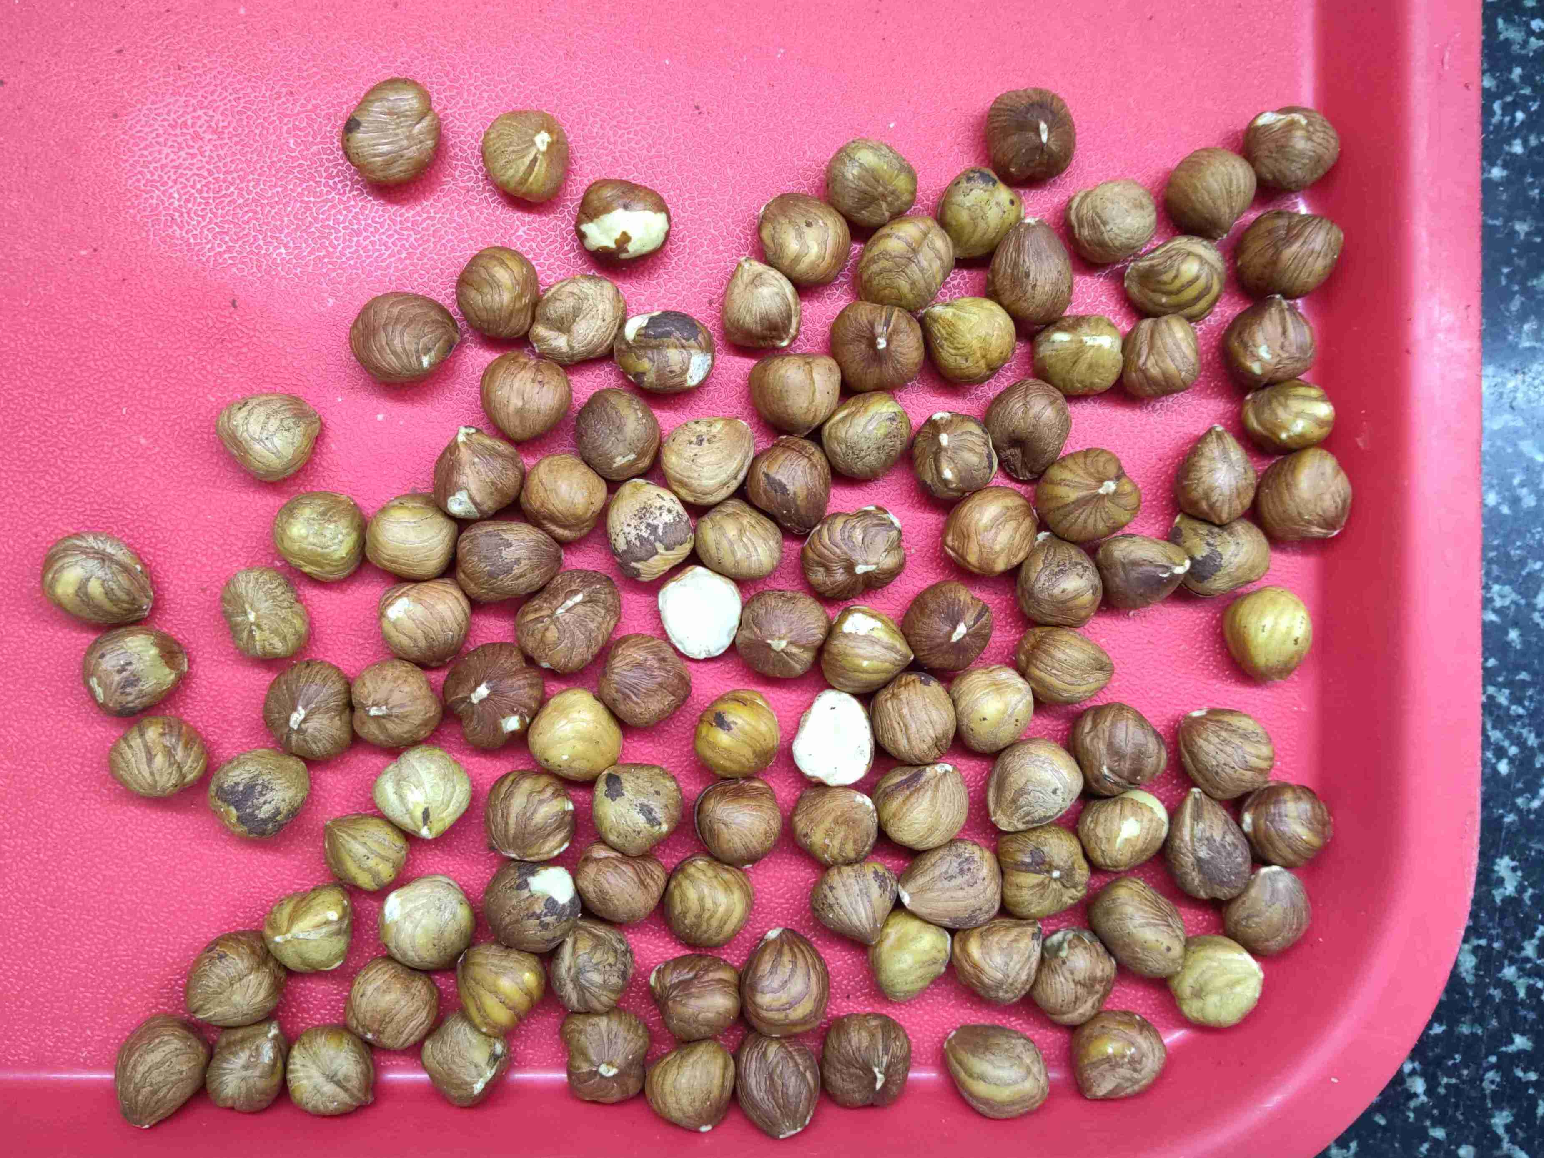
physical analysis | 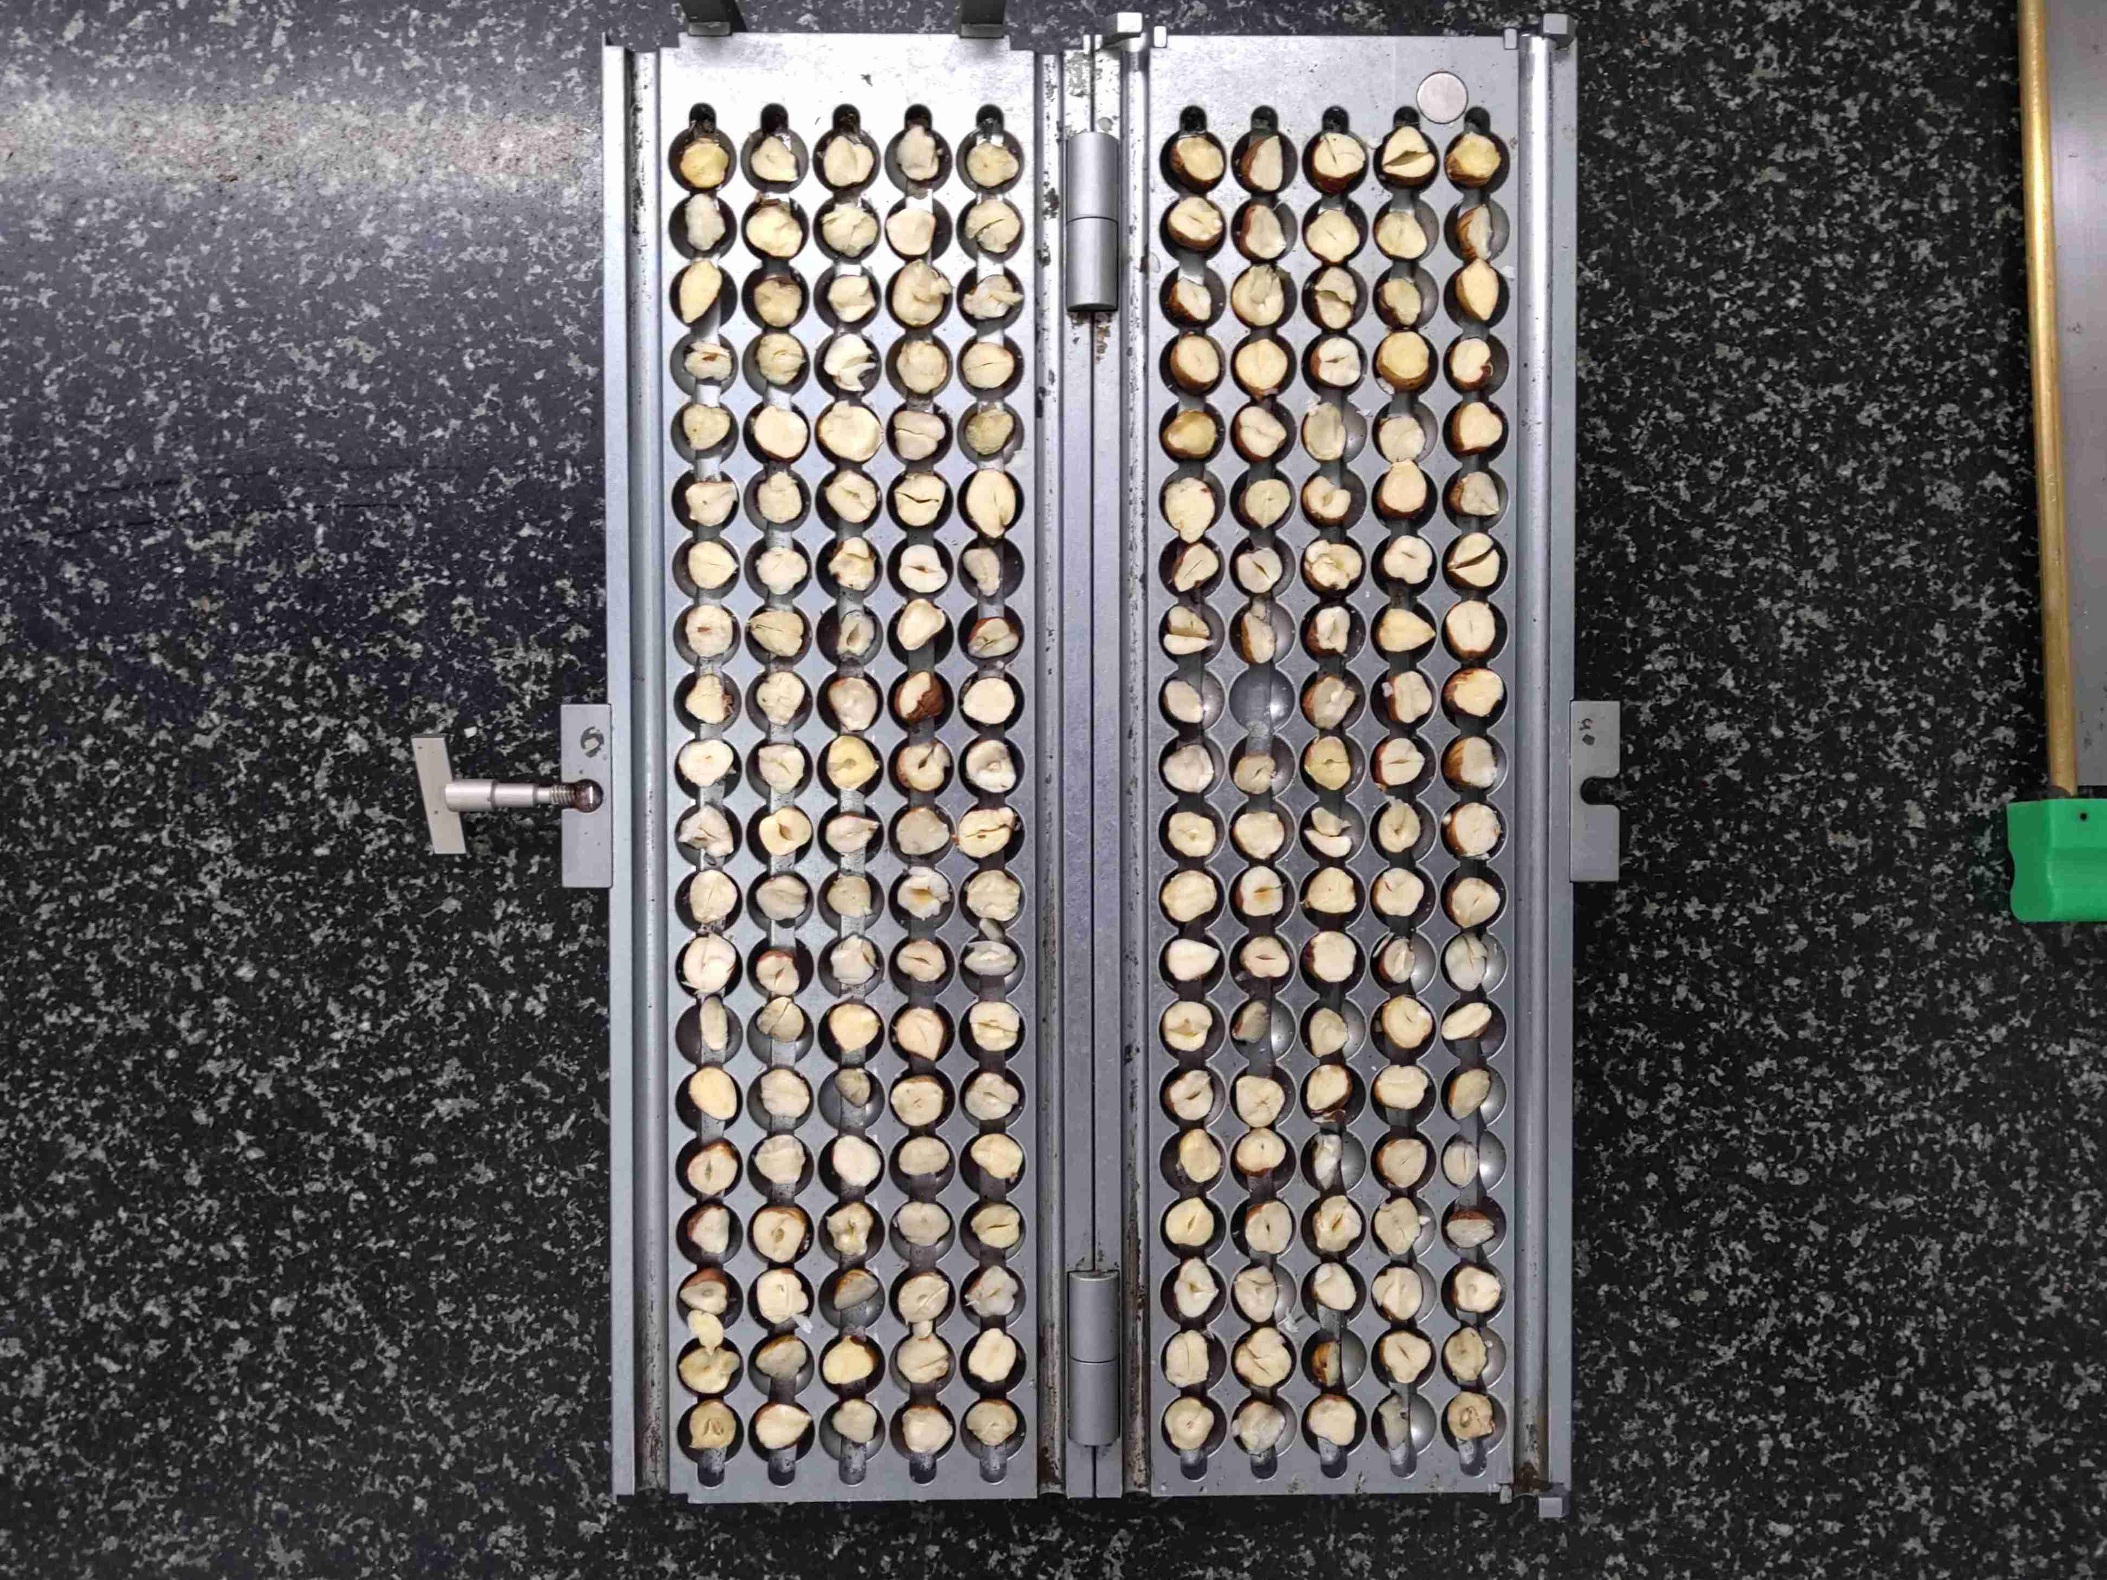
chipped/damaged | 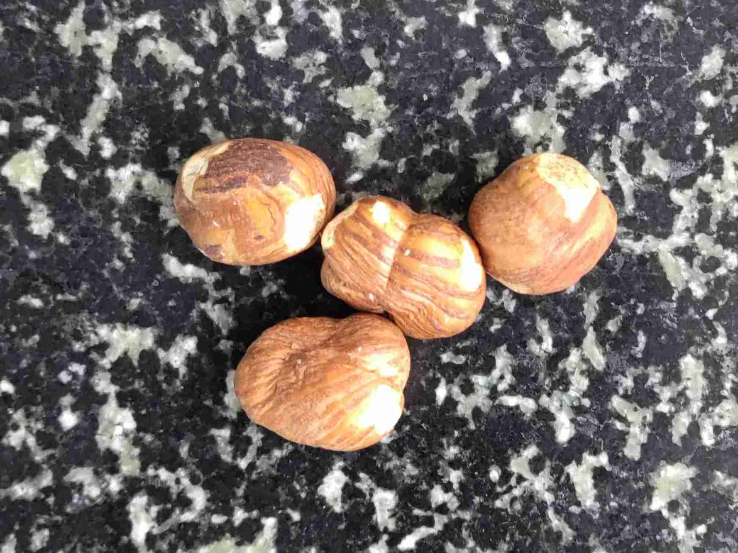
shrivelled | ${image#9}
rancid, rotten, bad smell | ${image#10}
insect damage | ${image#11}
rancid | ${image#12}
broken | ${image#13}
mould inside | ${image#14}
mould outside | ${image#15}

