
Samplingsheet Doraintrade 

Subject | 350020356/2-14-555
Order | 4502770009
label | 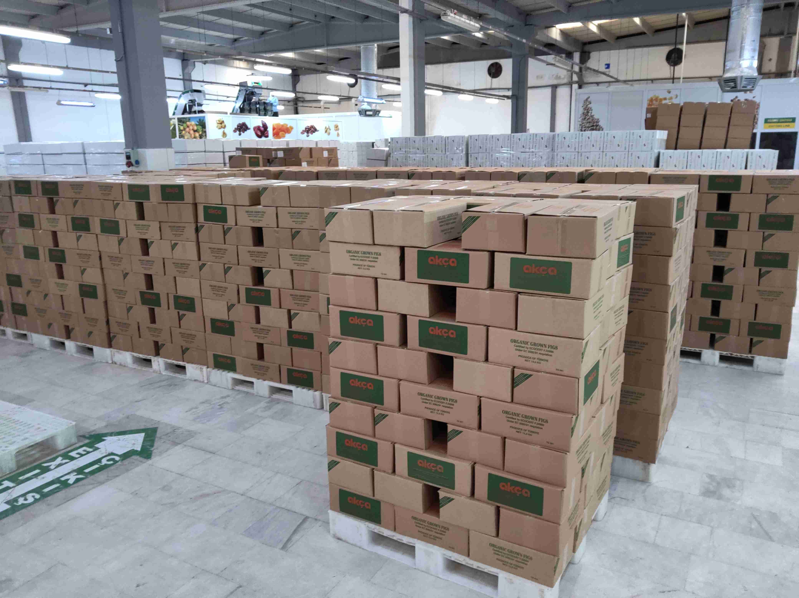
product cartons | 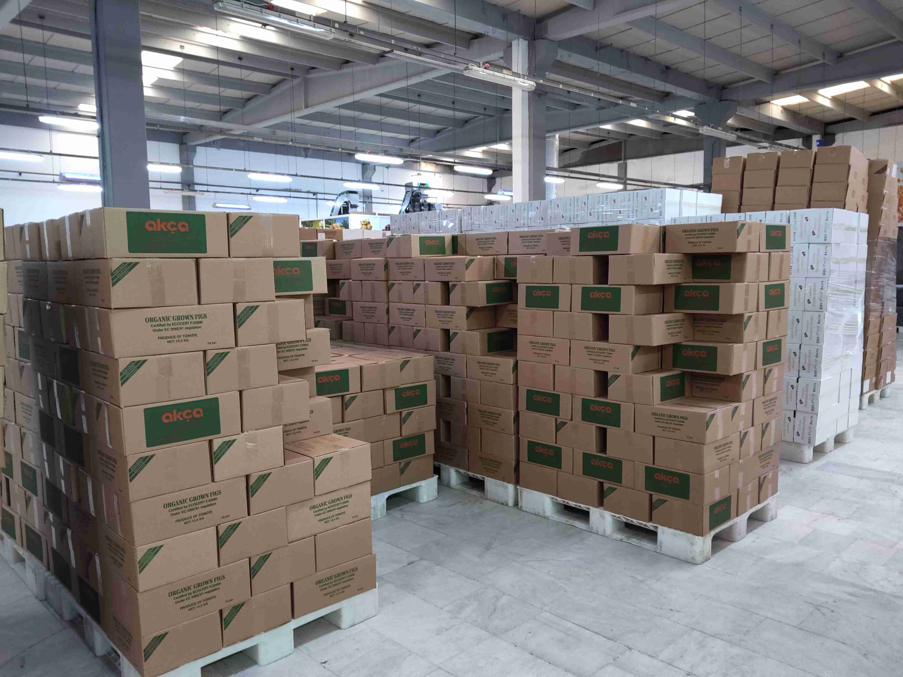
sampling | 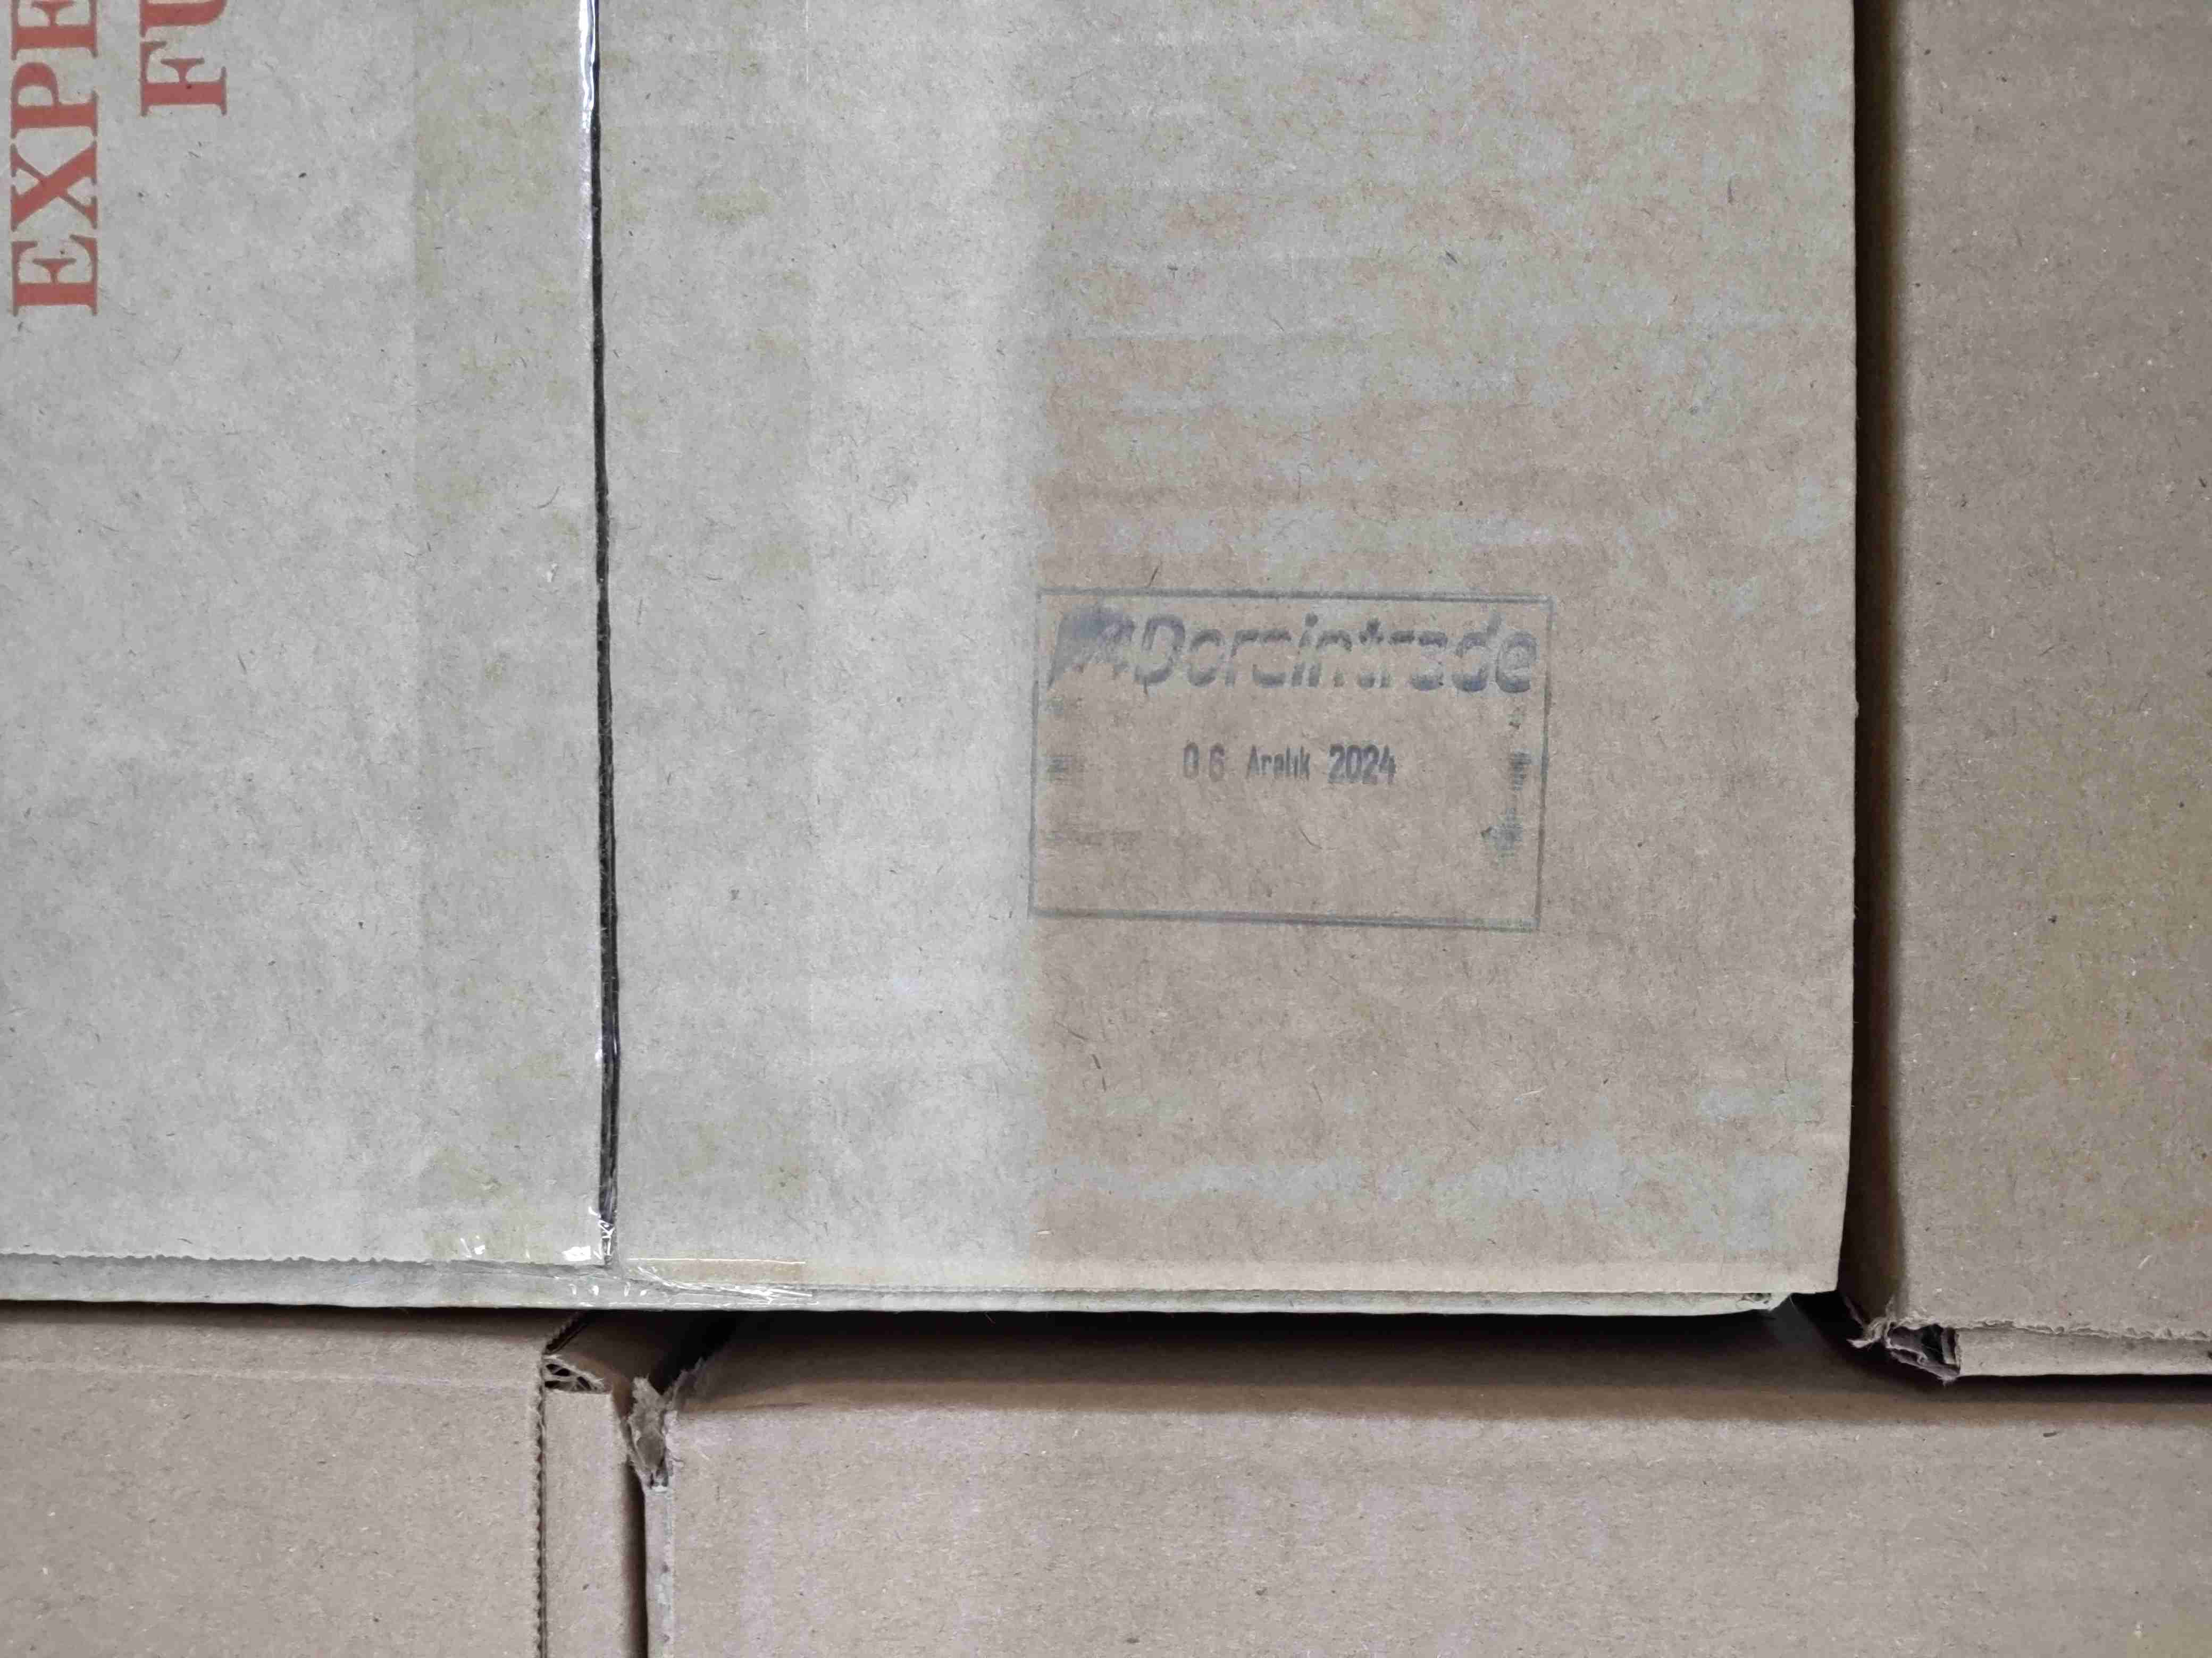
doraintrade stamp | 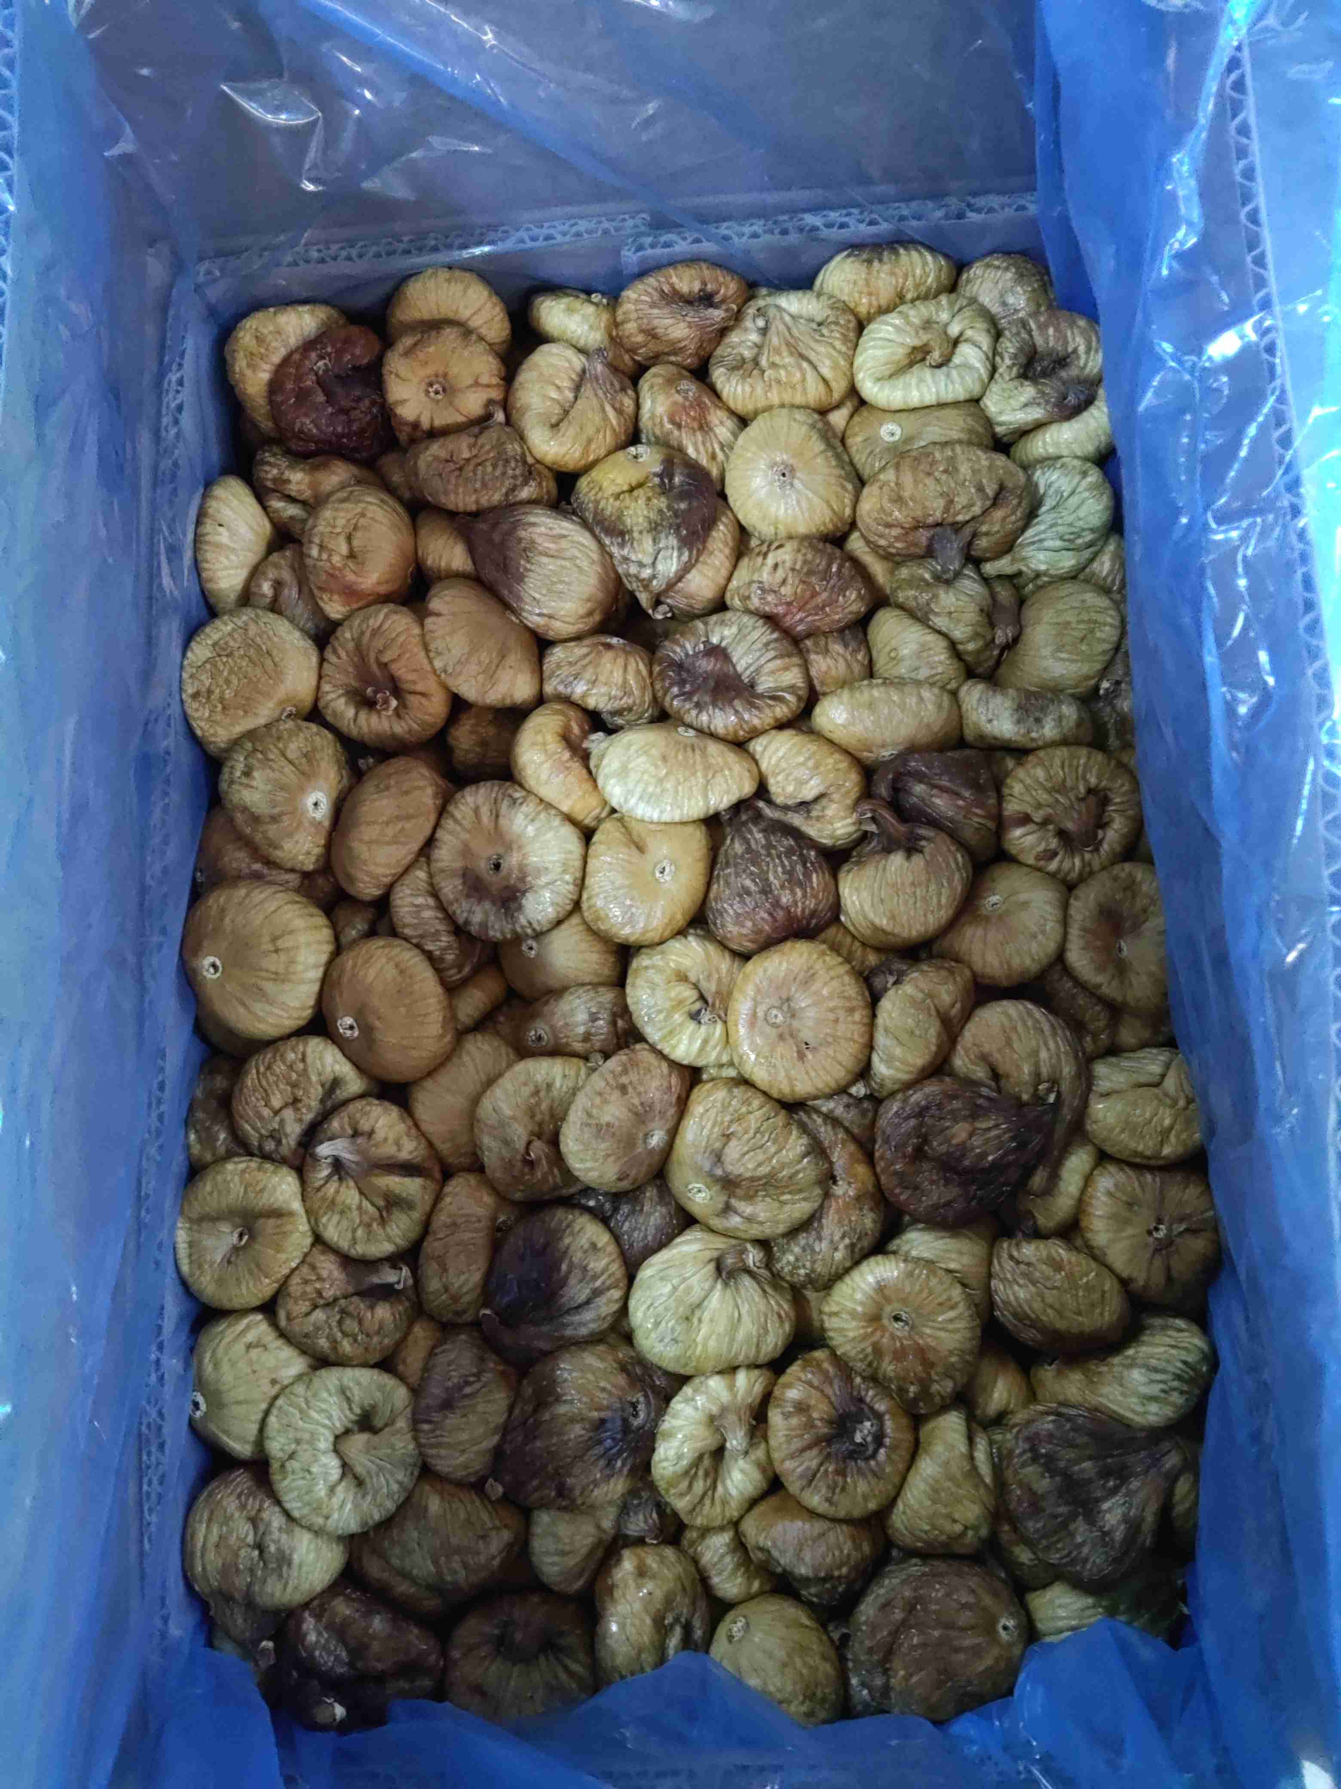
product | 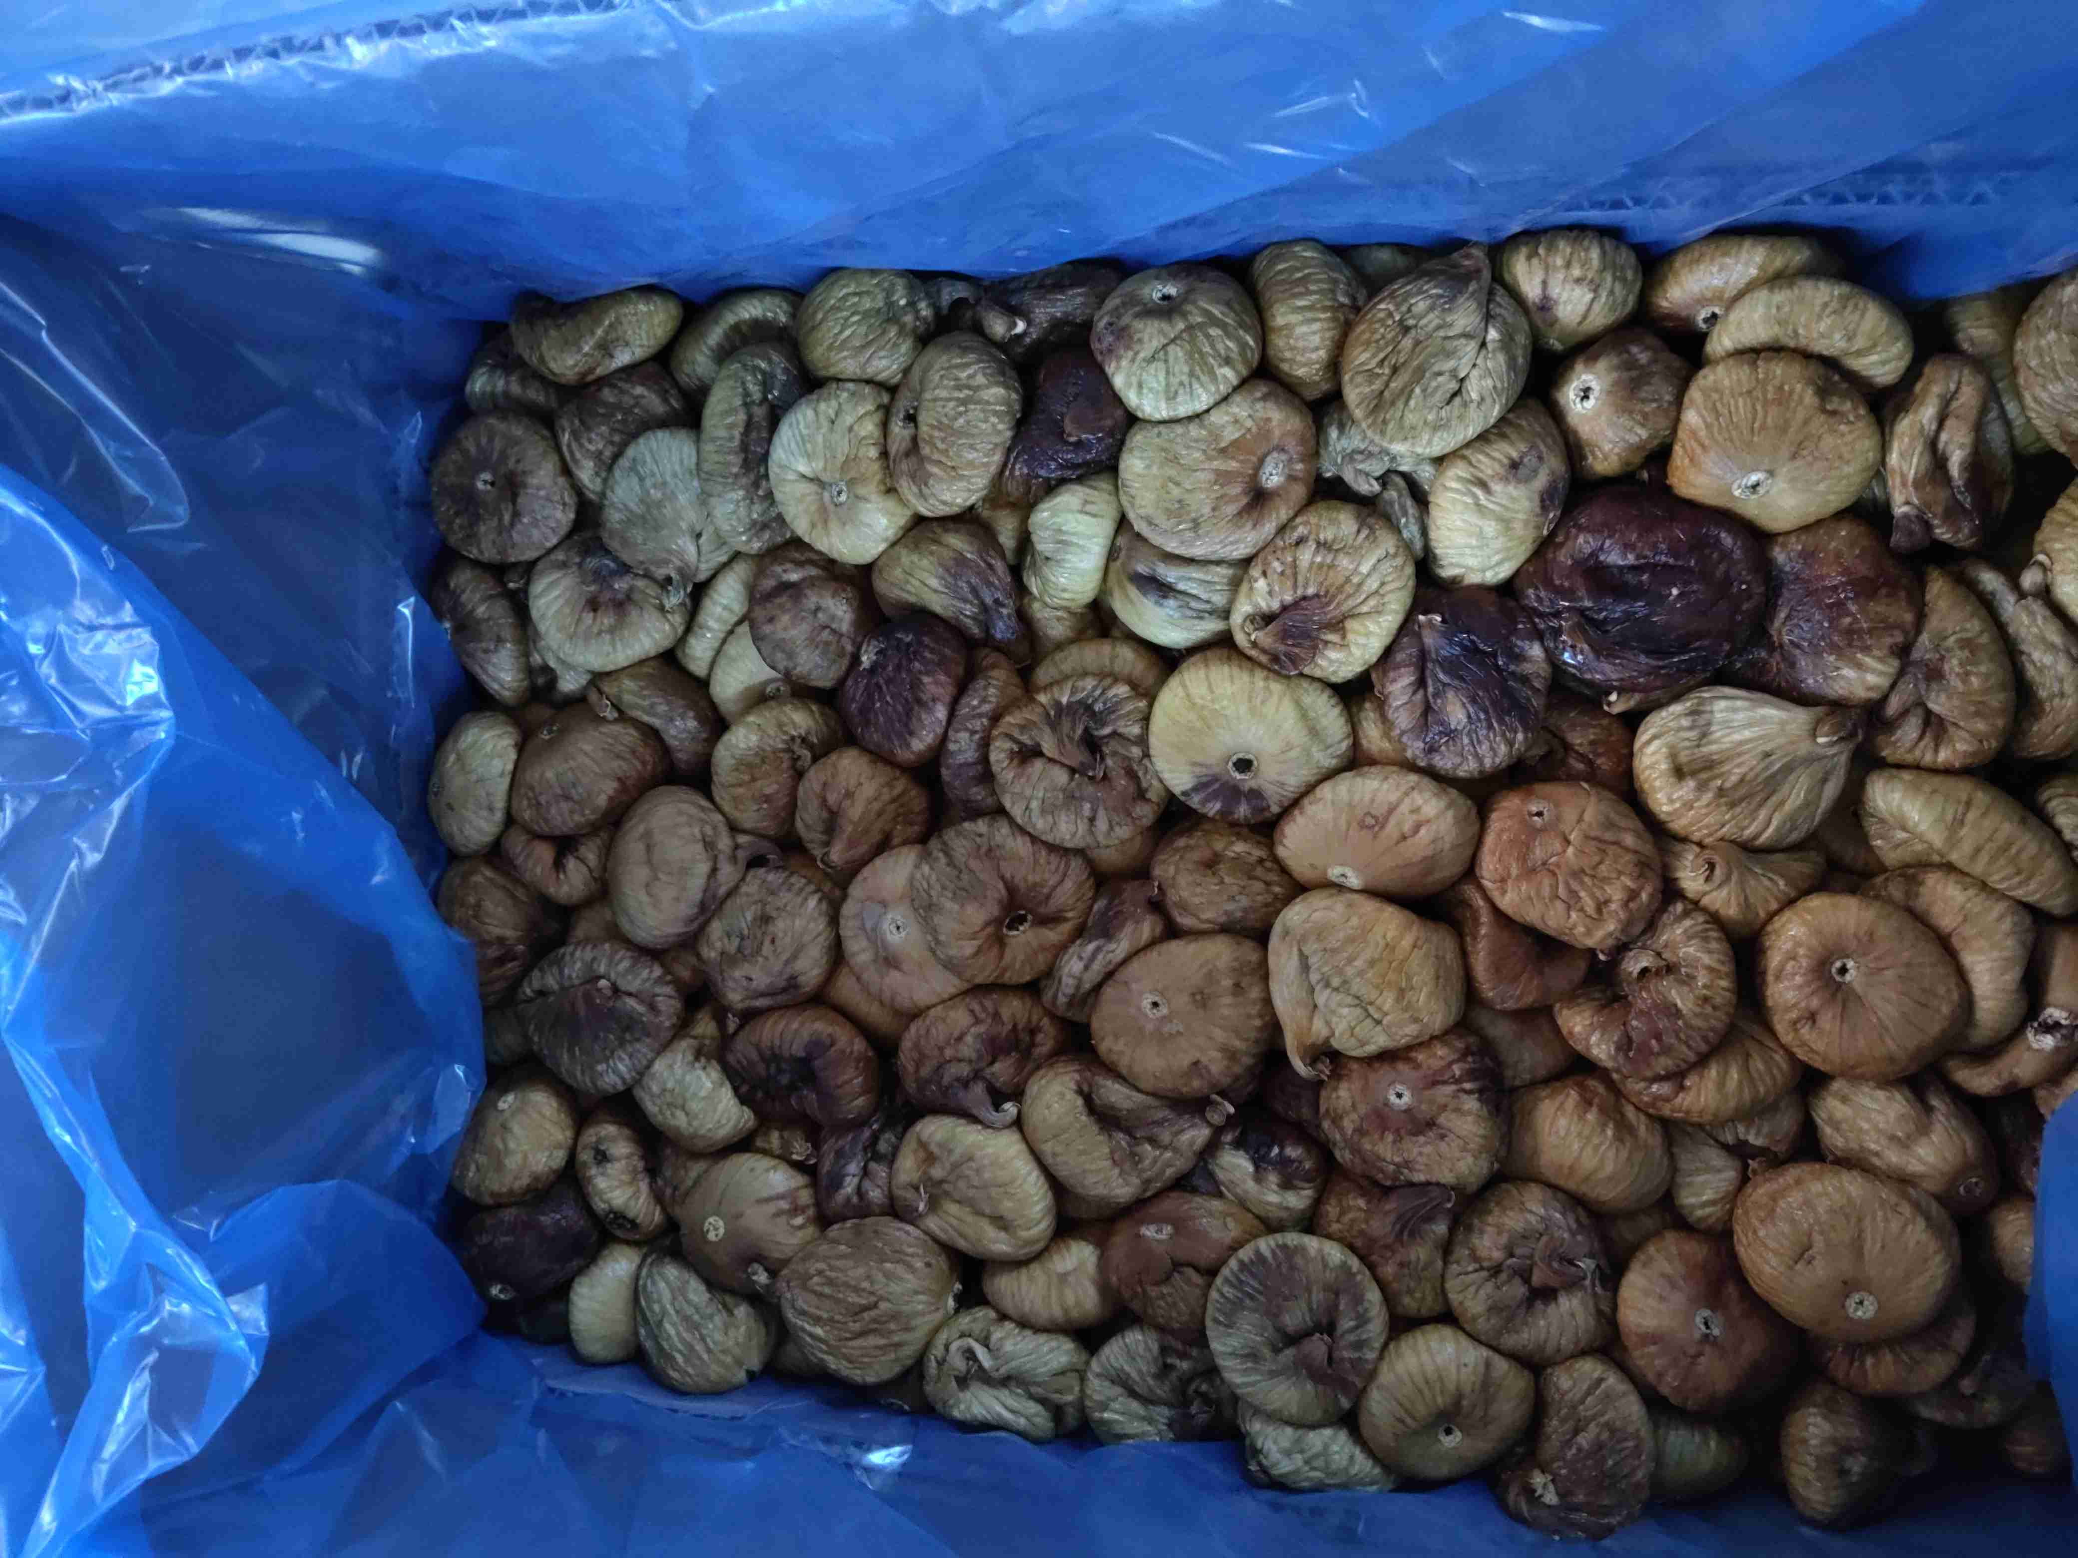
product | ${image#6}
physical analysis sample | ${image#7}
Damage Fruits | ${image#8}
Sunburn | ${image#9}
spotted fruits | ${image#10}
Open Fruits | ${image#11}
Souring/Fermenting | ${image#12}
Mould/Black Mould | ${image#13}

