
Samplingsheet Doraintrade 

Subject | 350020119/1-02-240917
Order | 4502856146
label | 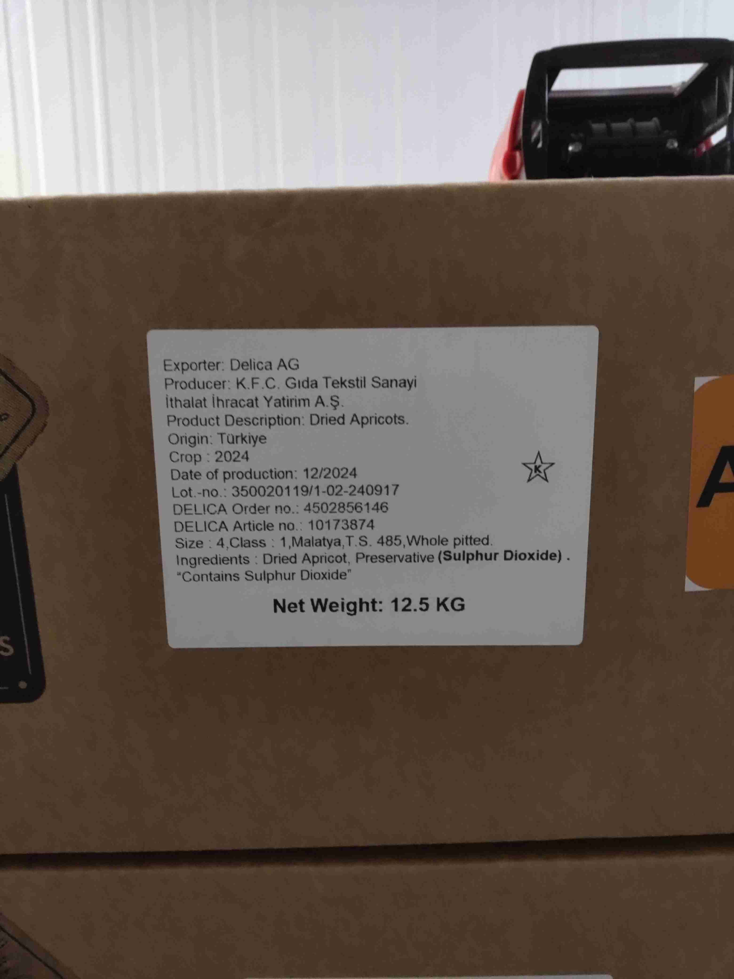
product cartons | 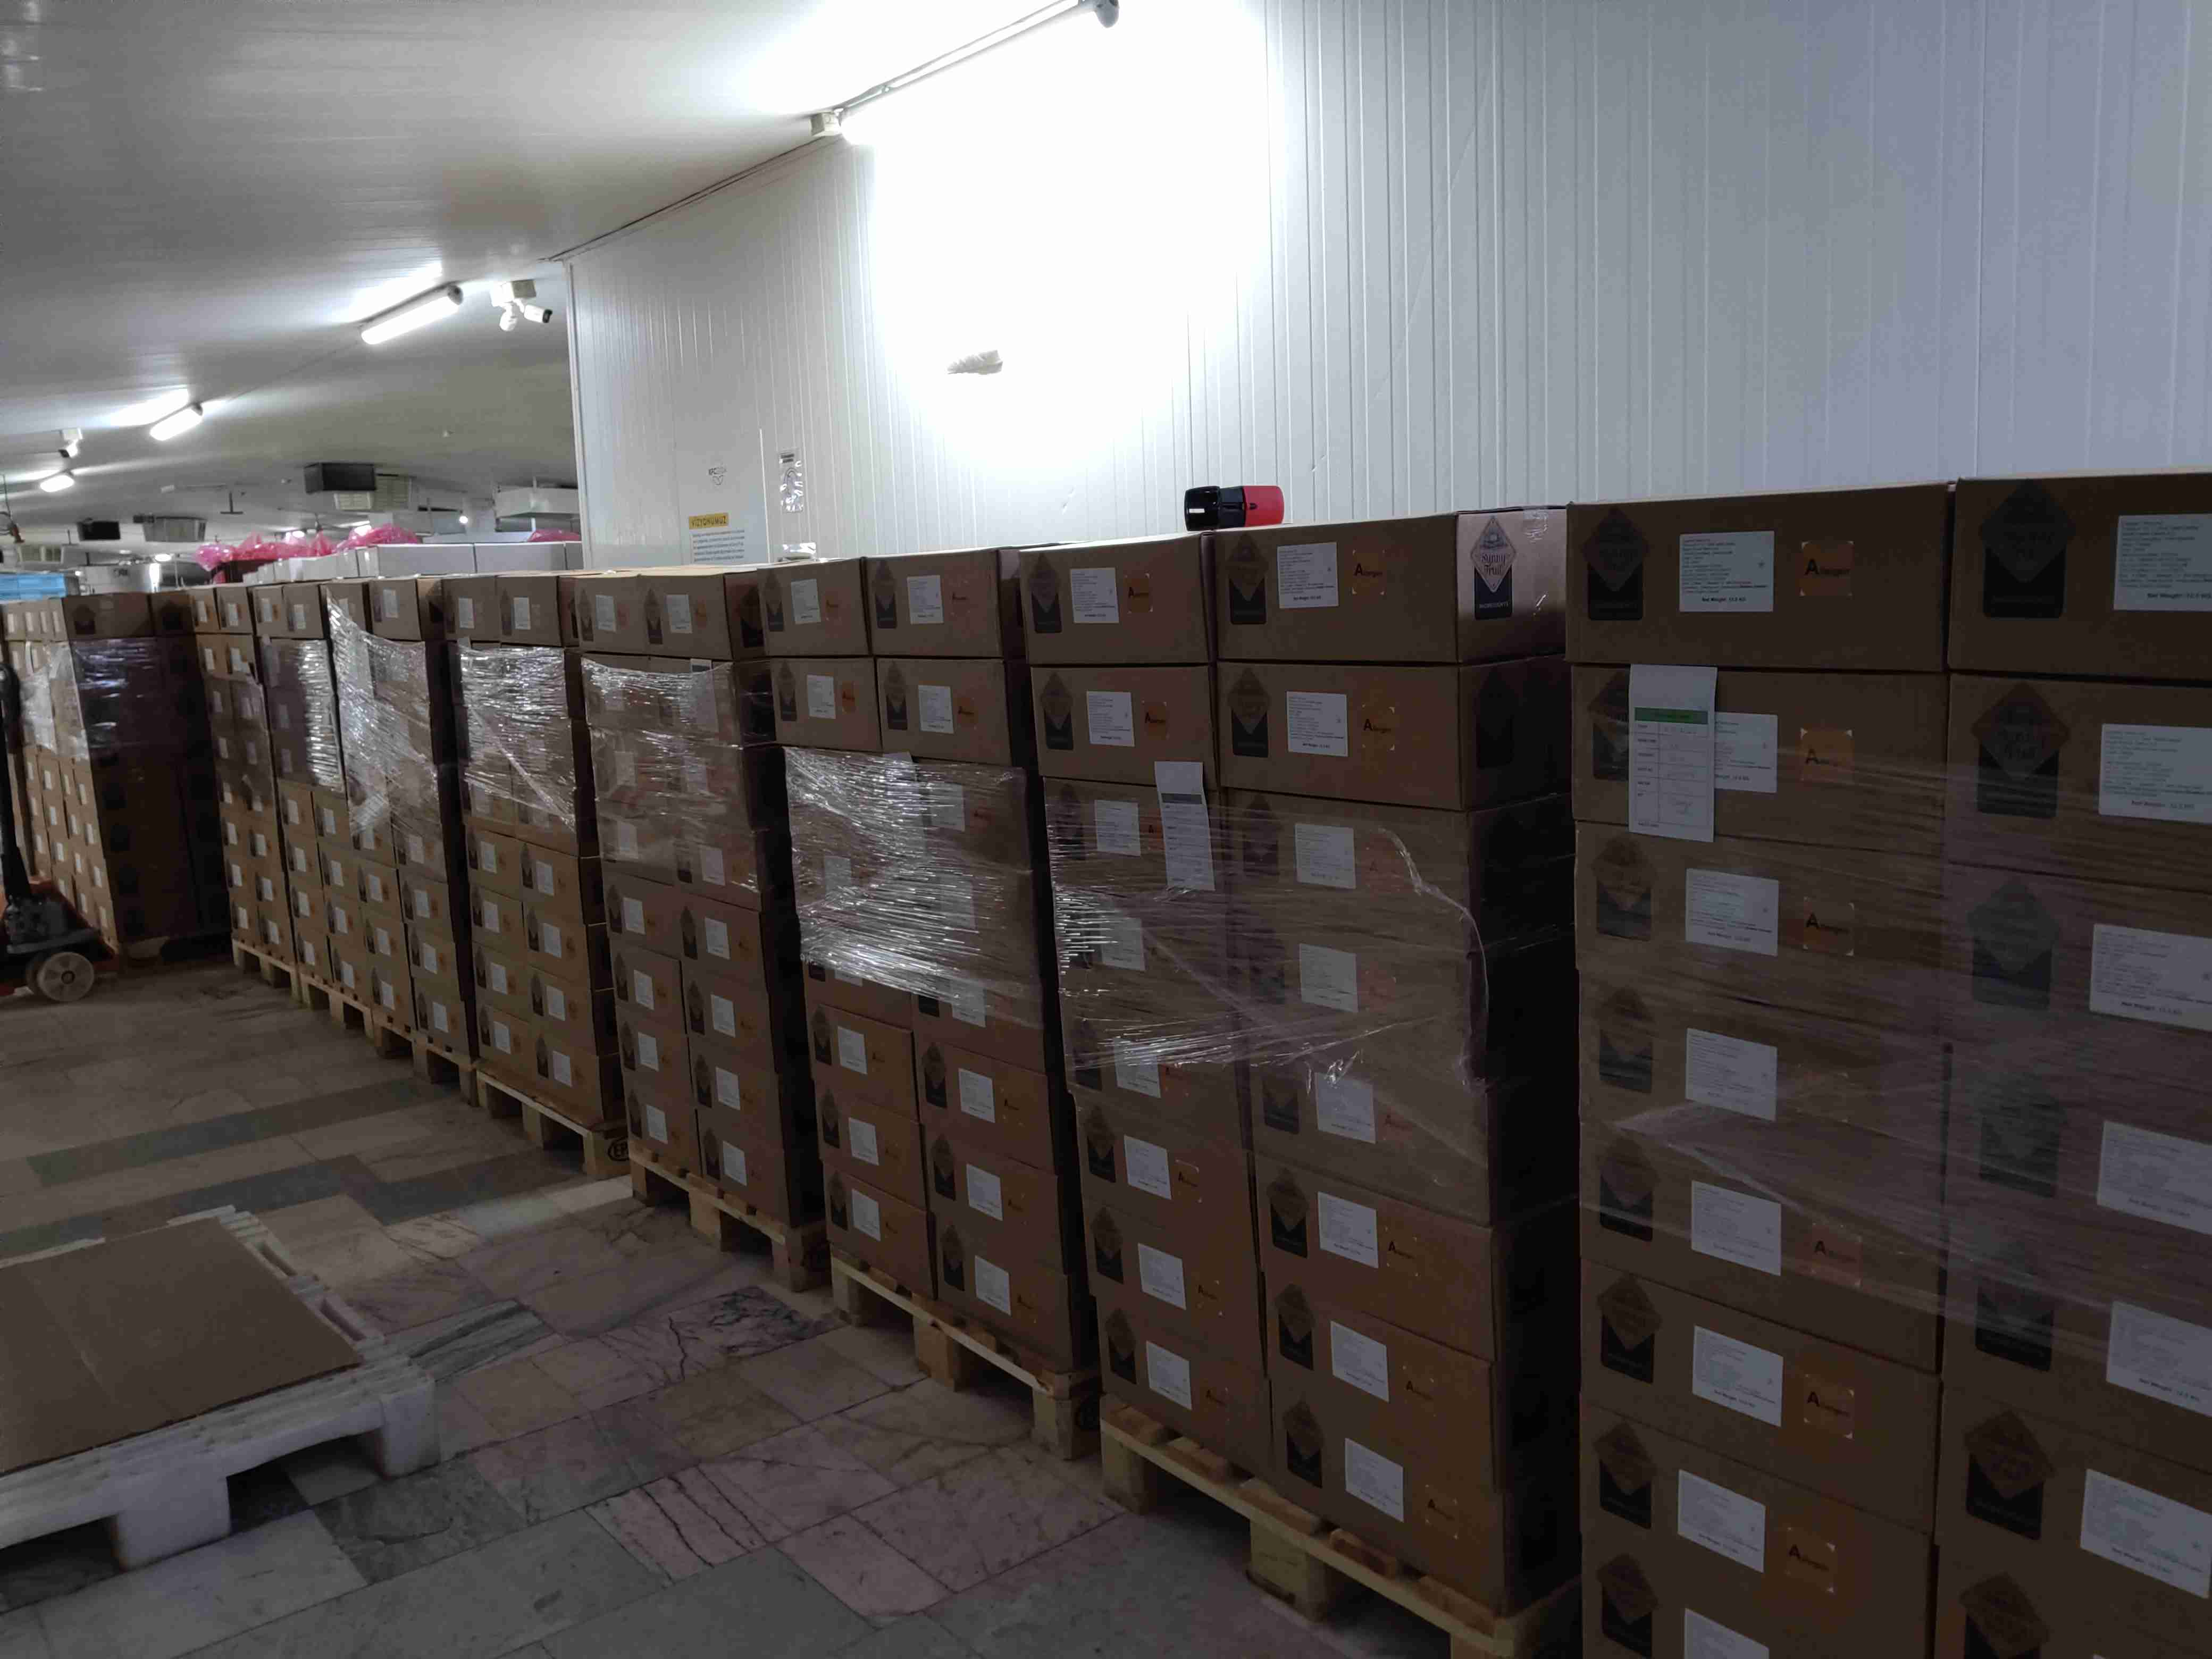
sampling | 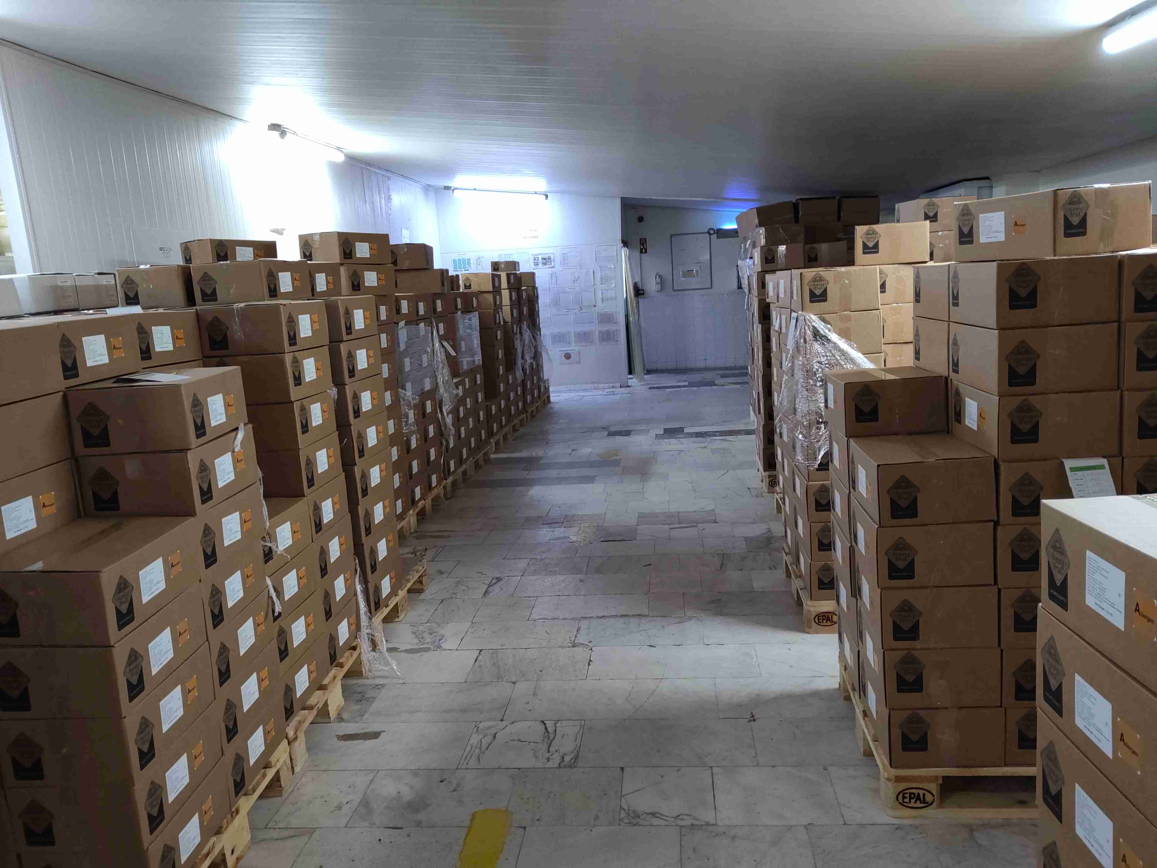
Insect Damage | ${image#4}
Color Deviation/Sunburn | ${image#5}
Stained/spotty | ${image#6}
Torn/split | ${image#7}
Doraintrade stamp | ${image#8}
Embedded dirt, sand | ${image#9}
mix sample | ${image#10}

