
Samplingsheet Doraintrade 

Subject | 350020356/2-14-726
Order | 4502860590
label | 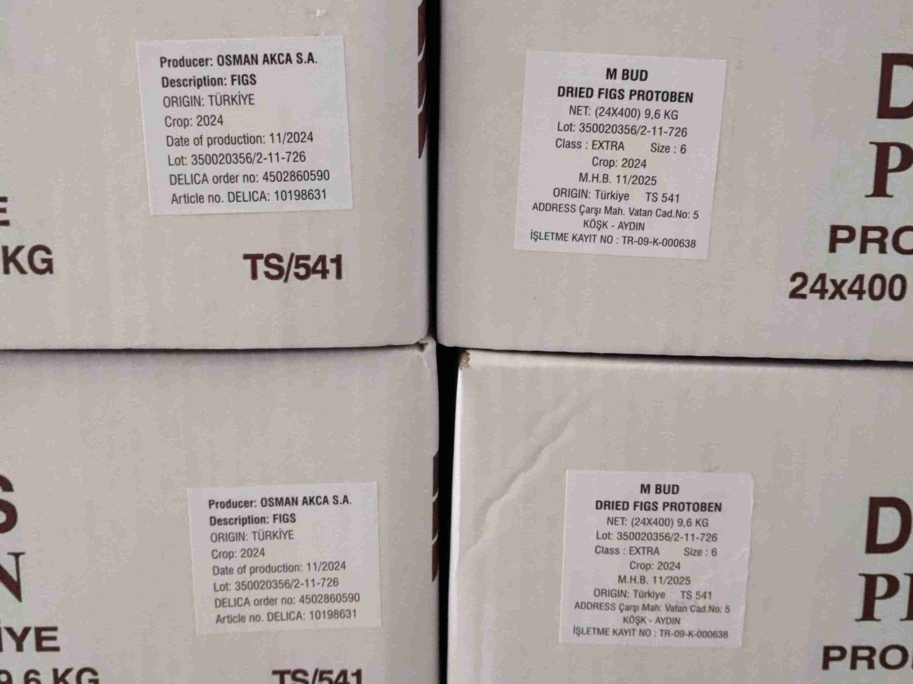
product cartons | 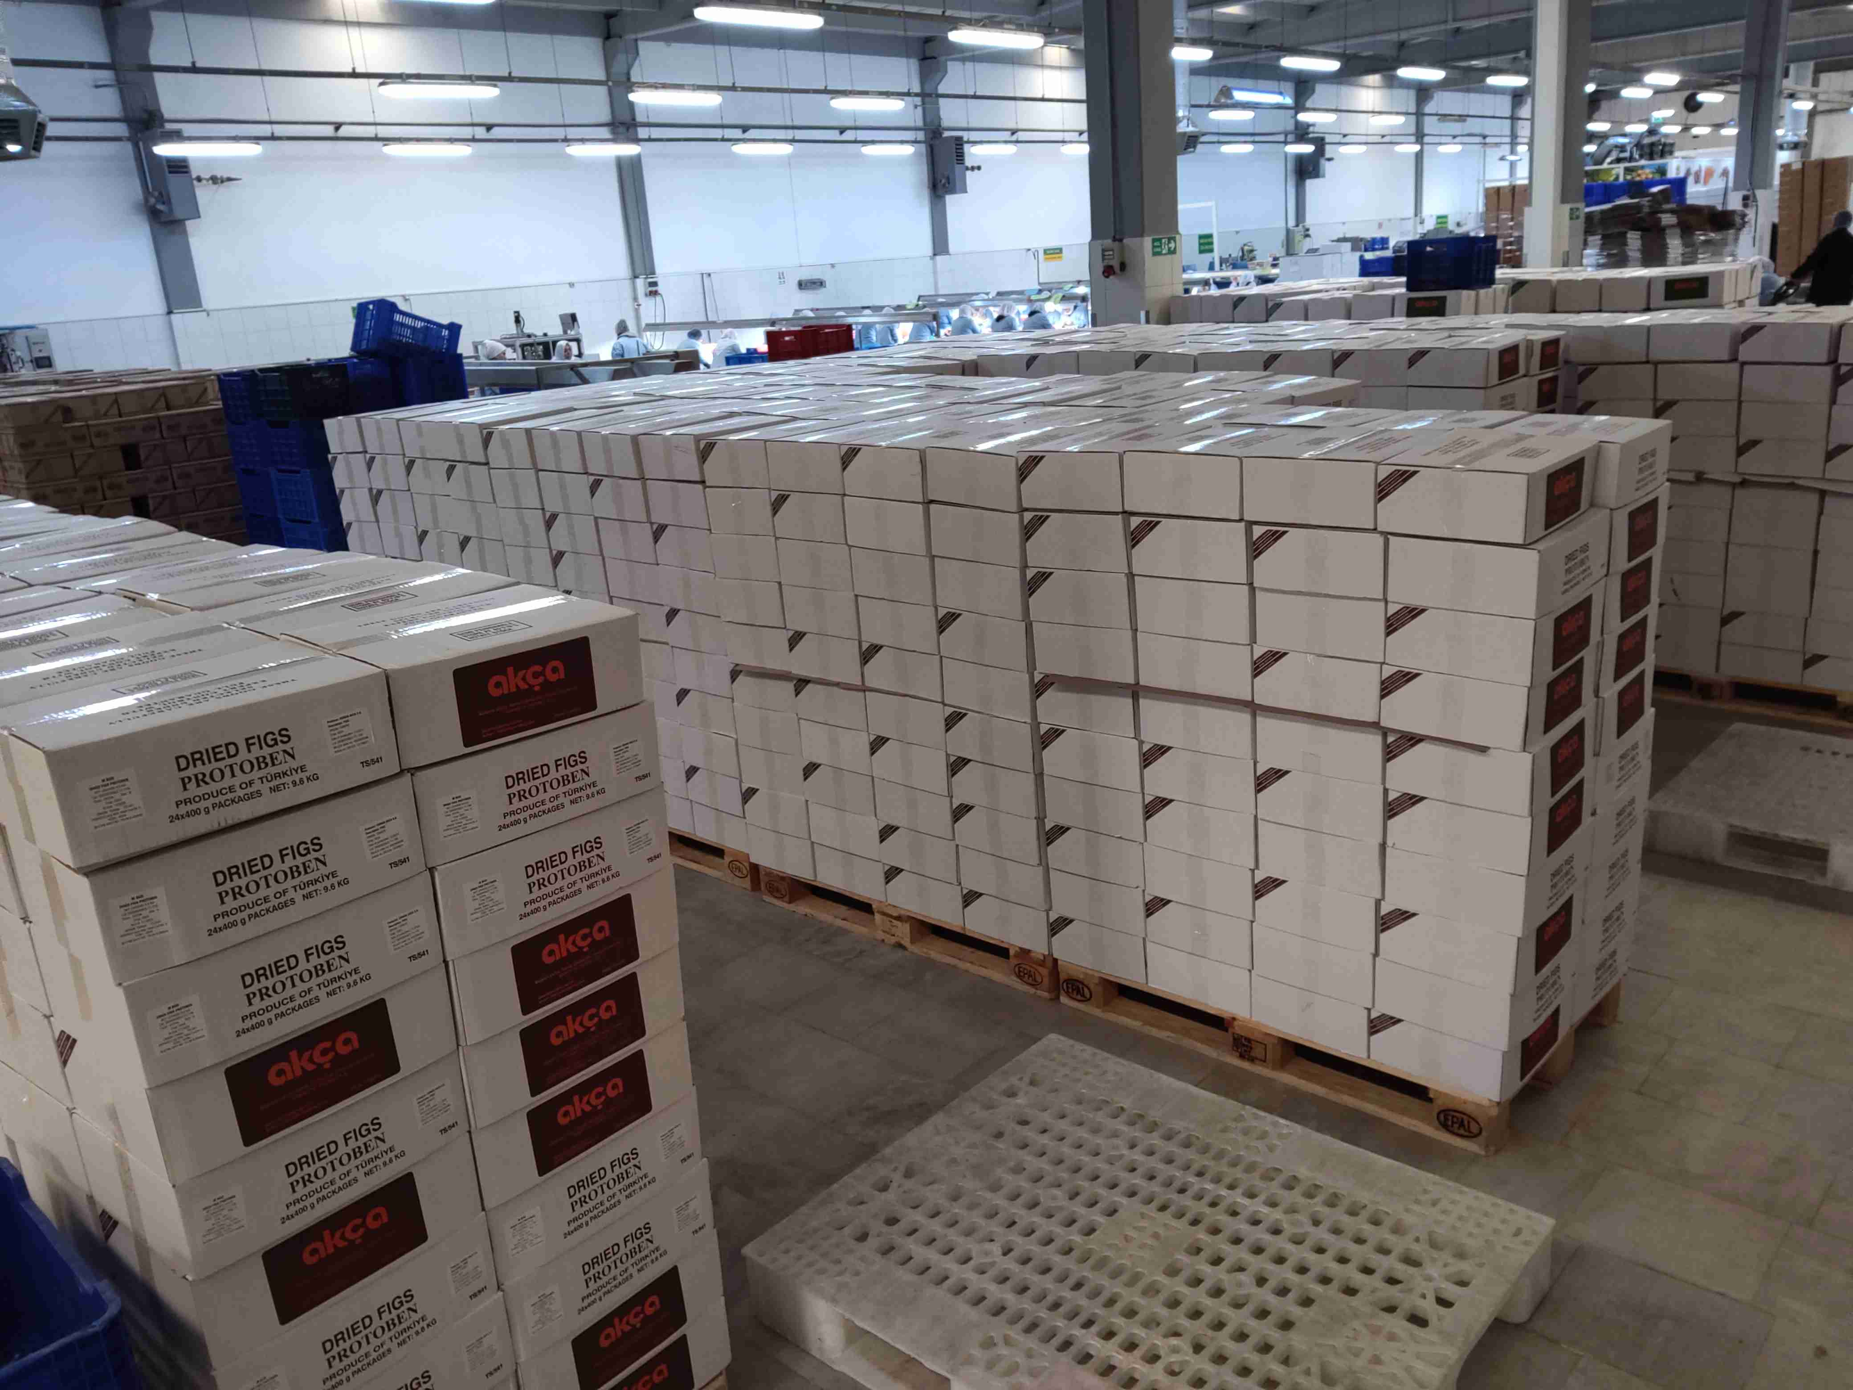
sampling | 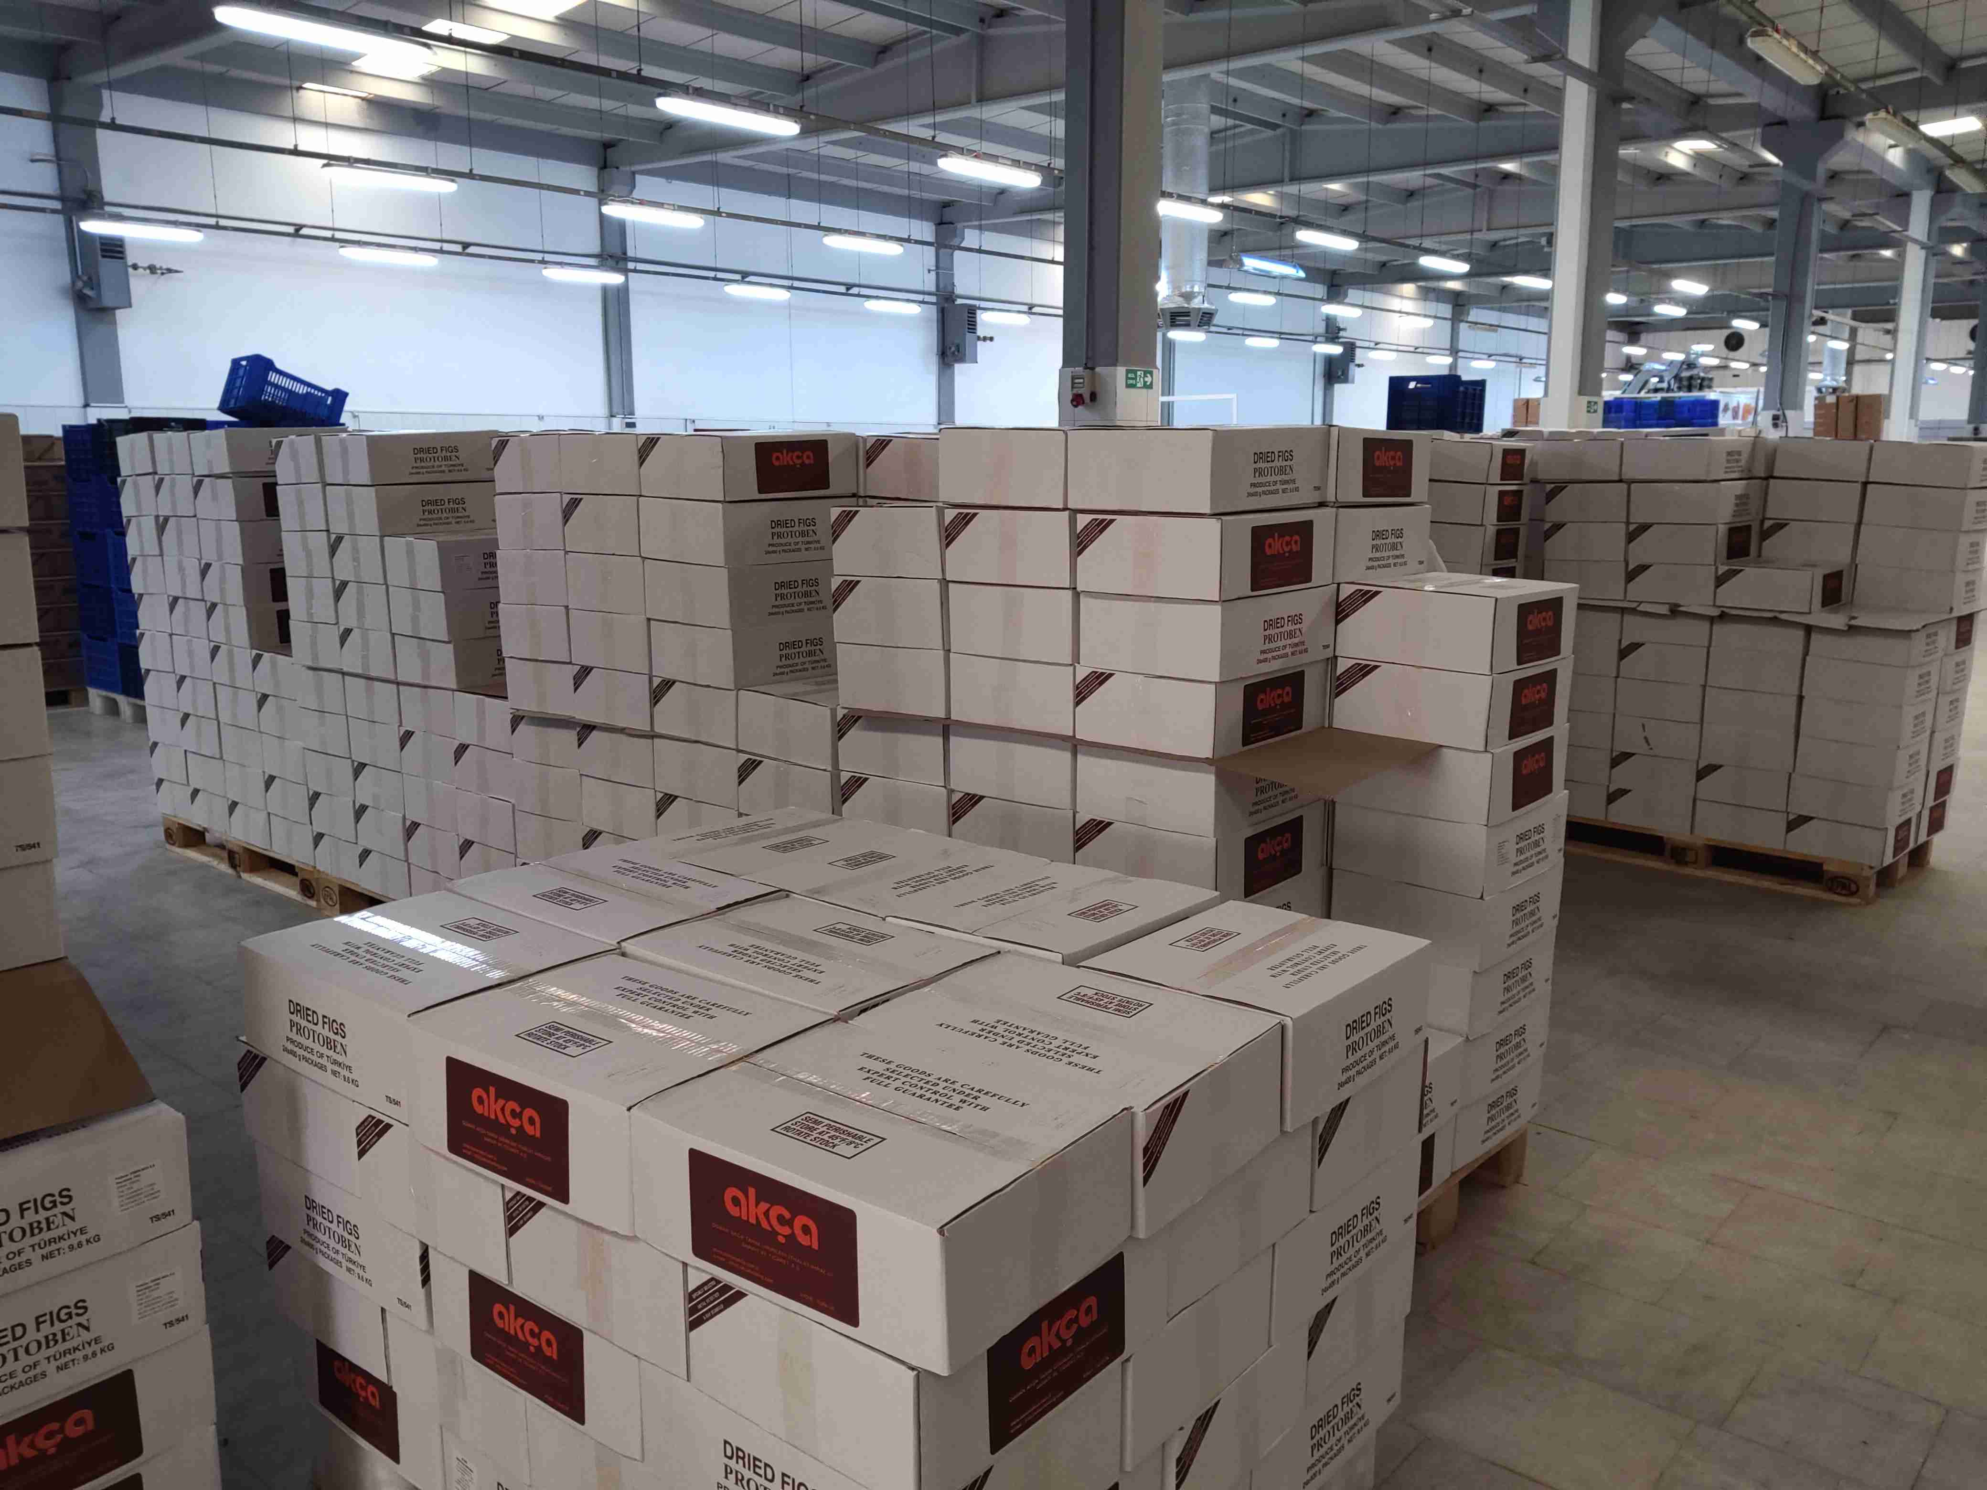
doraintrade stamp | 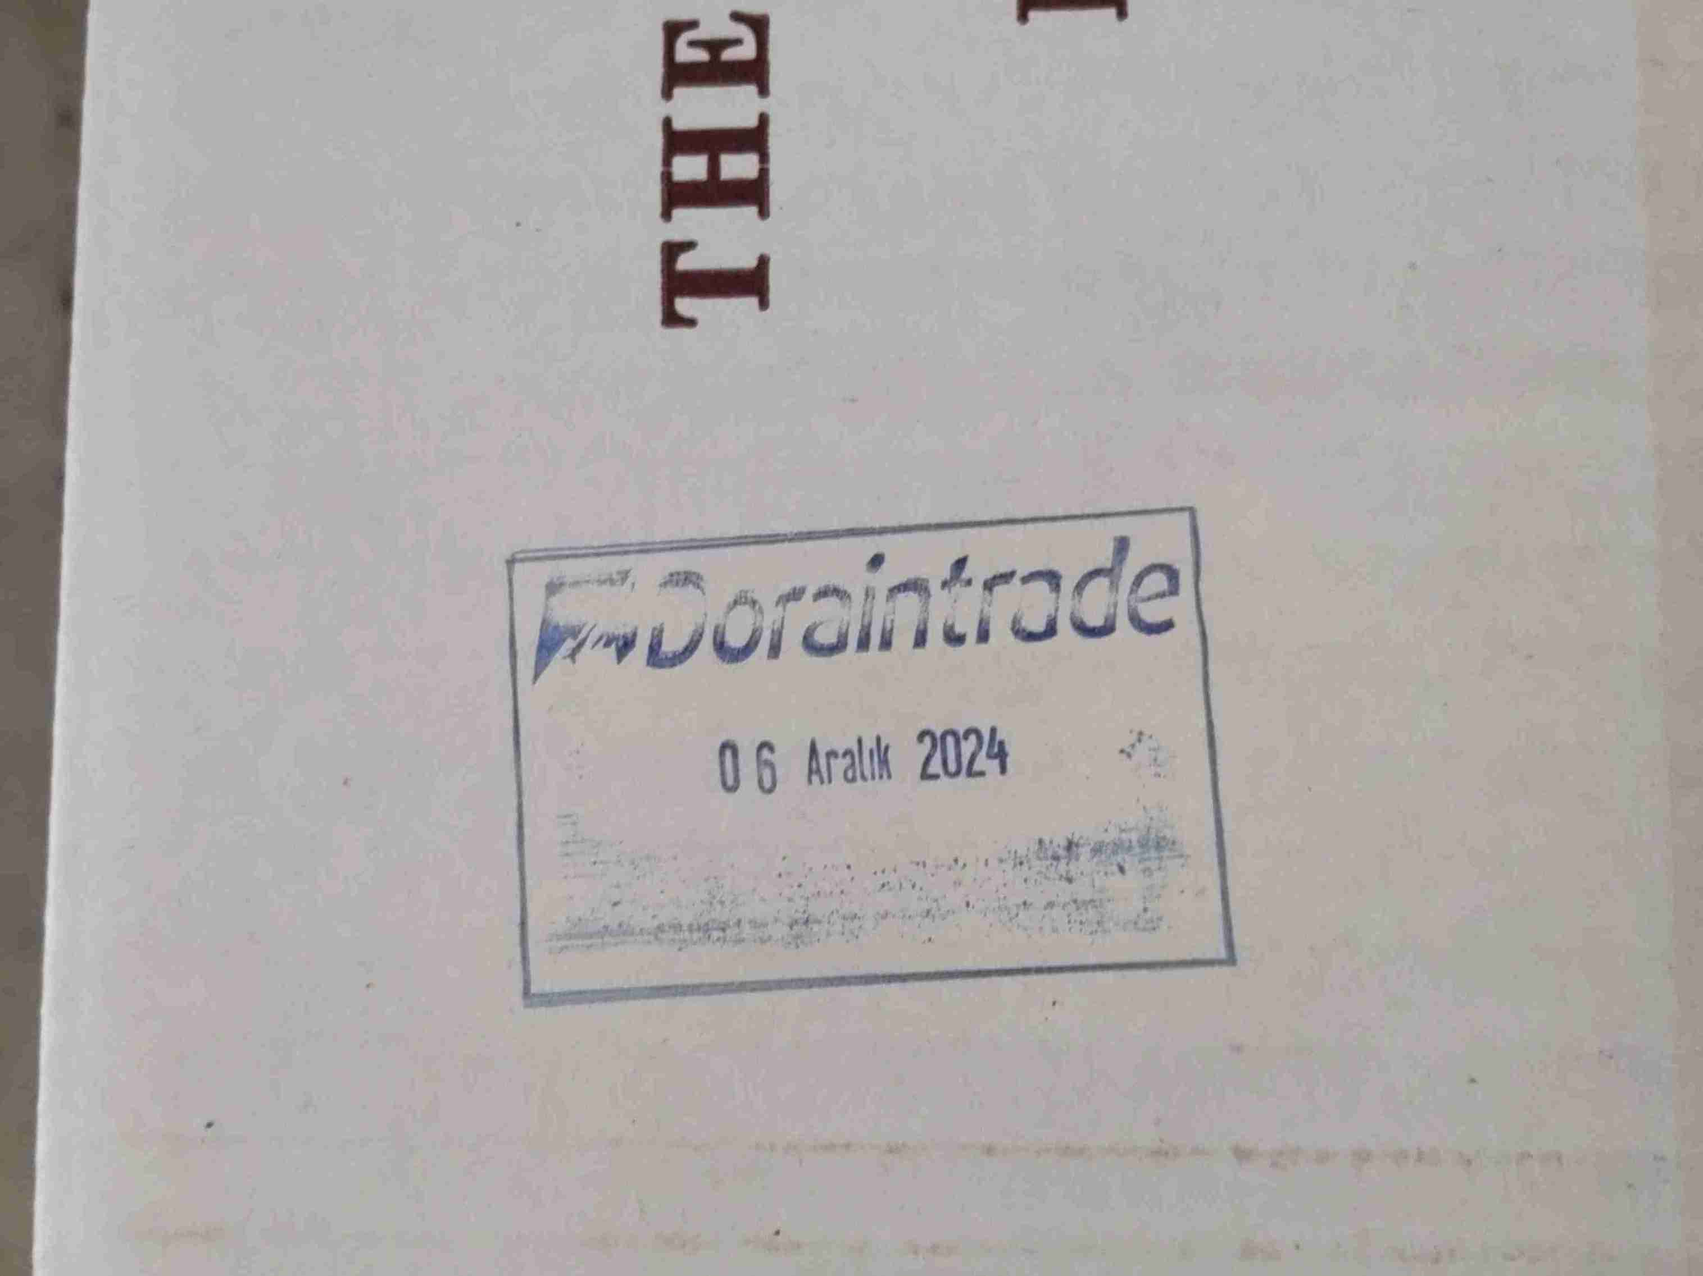
product | 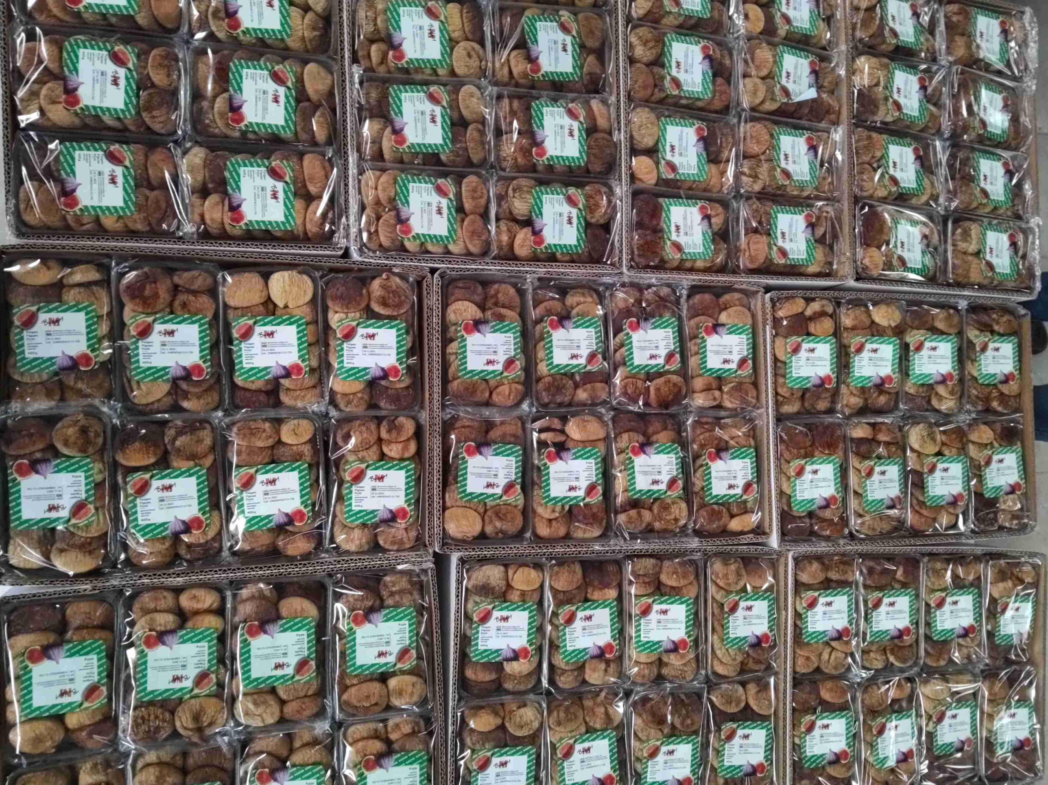
product | ${image#6}
product | ${image#7}
physical analysis sample | ${image#8}
Insect Damage | ${image#9}
Mould/Black Mould | ${image#10}
Souring/Fermenting | ${image#11}
Seriously Damaged Fruits | ${image#12}

