
Samplingsheet Doraintrade 

Subject | 350020356/2-11-
Order | 4502860614
label | 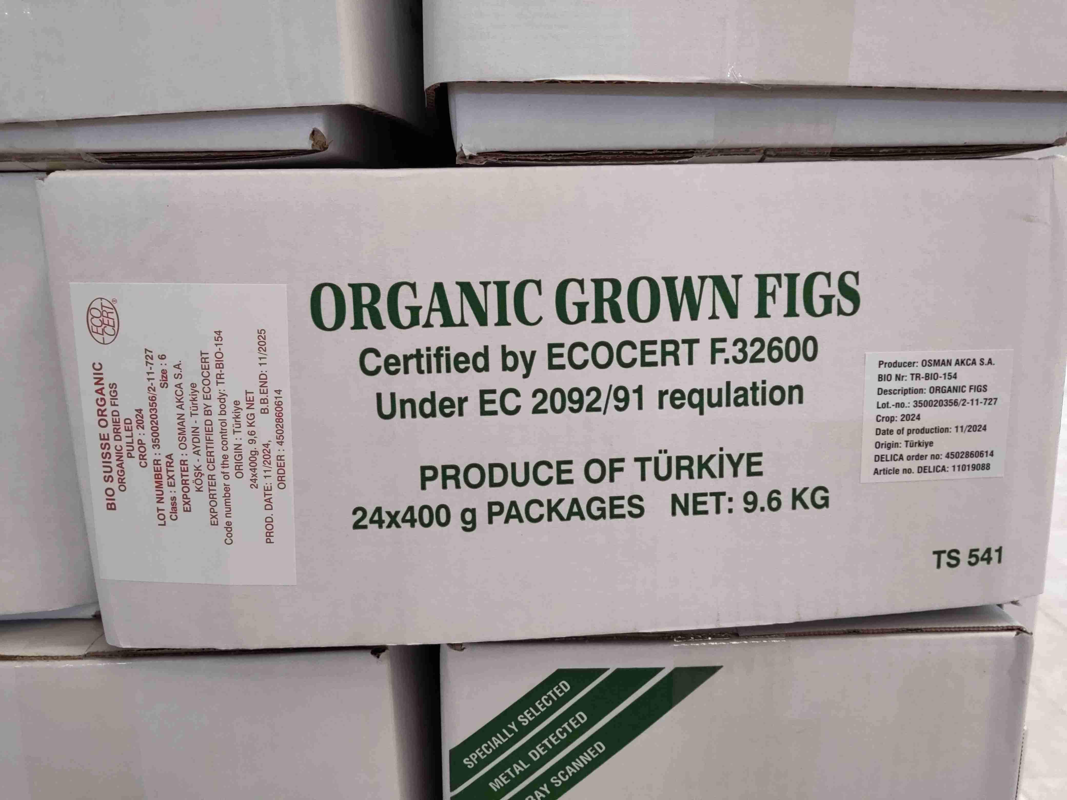
Product Cartons | 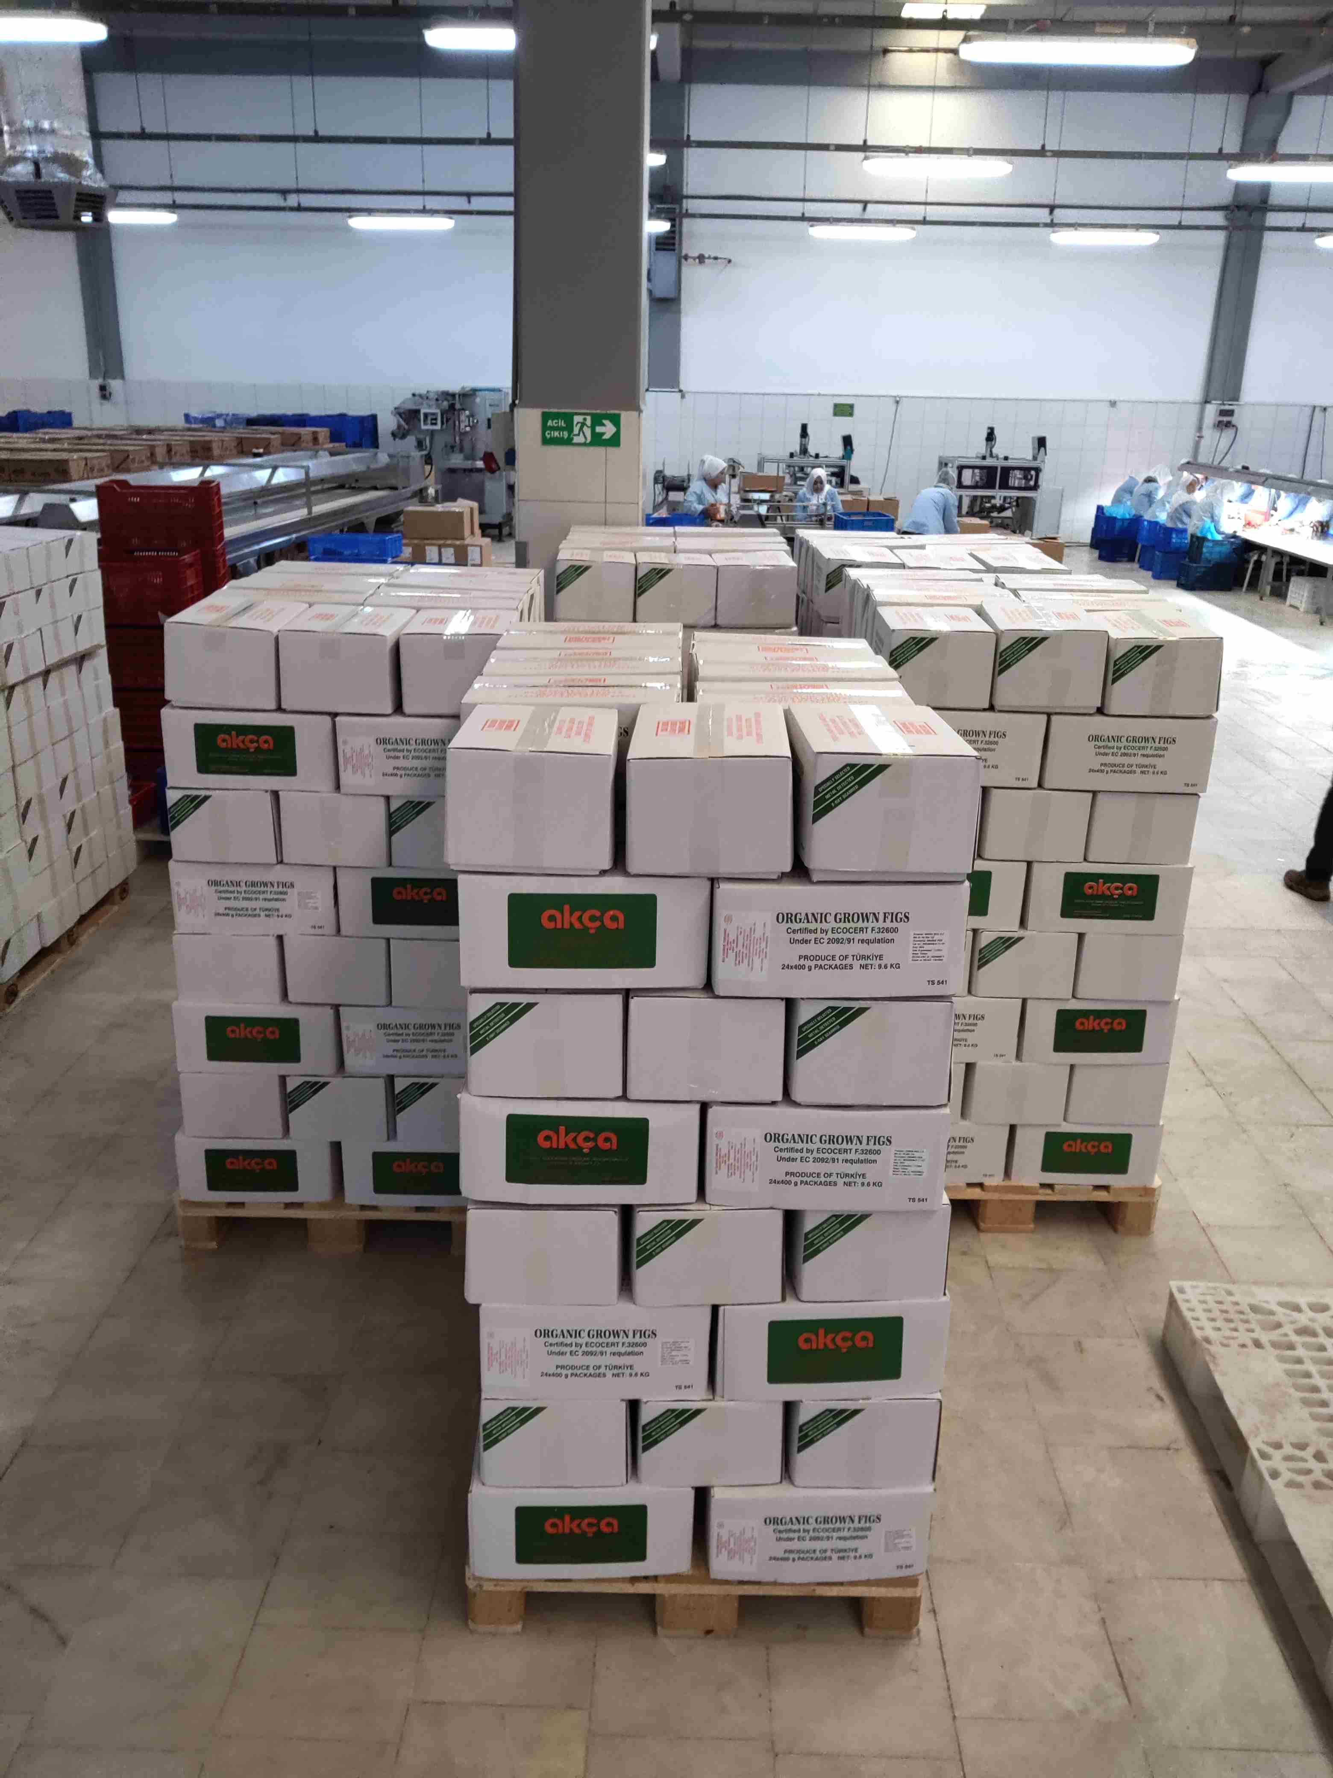
Sampling Cartons | 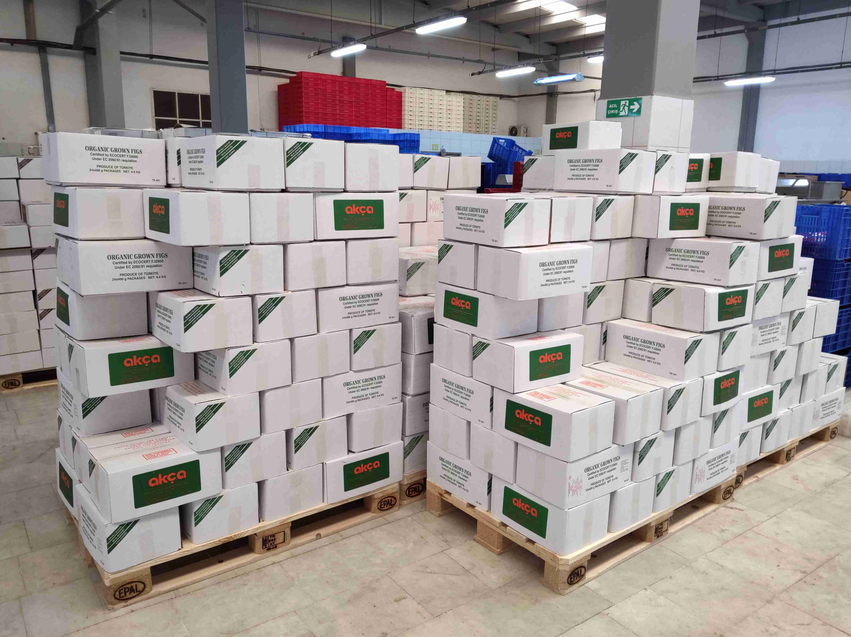
Sampling | 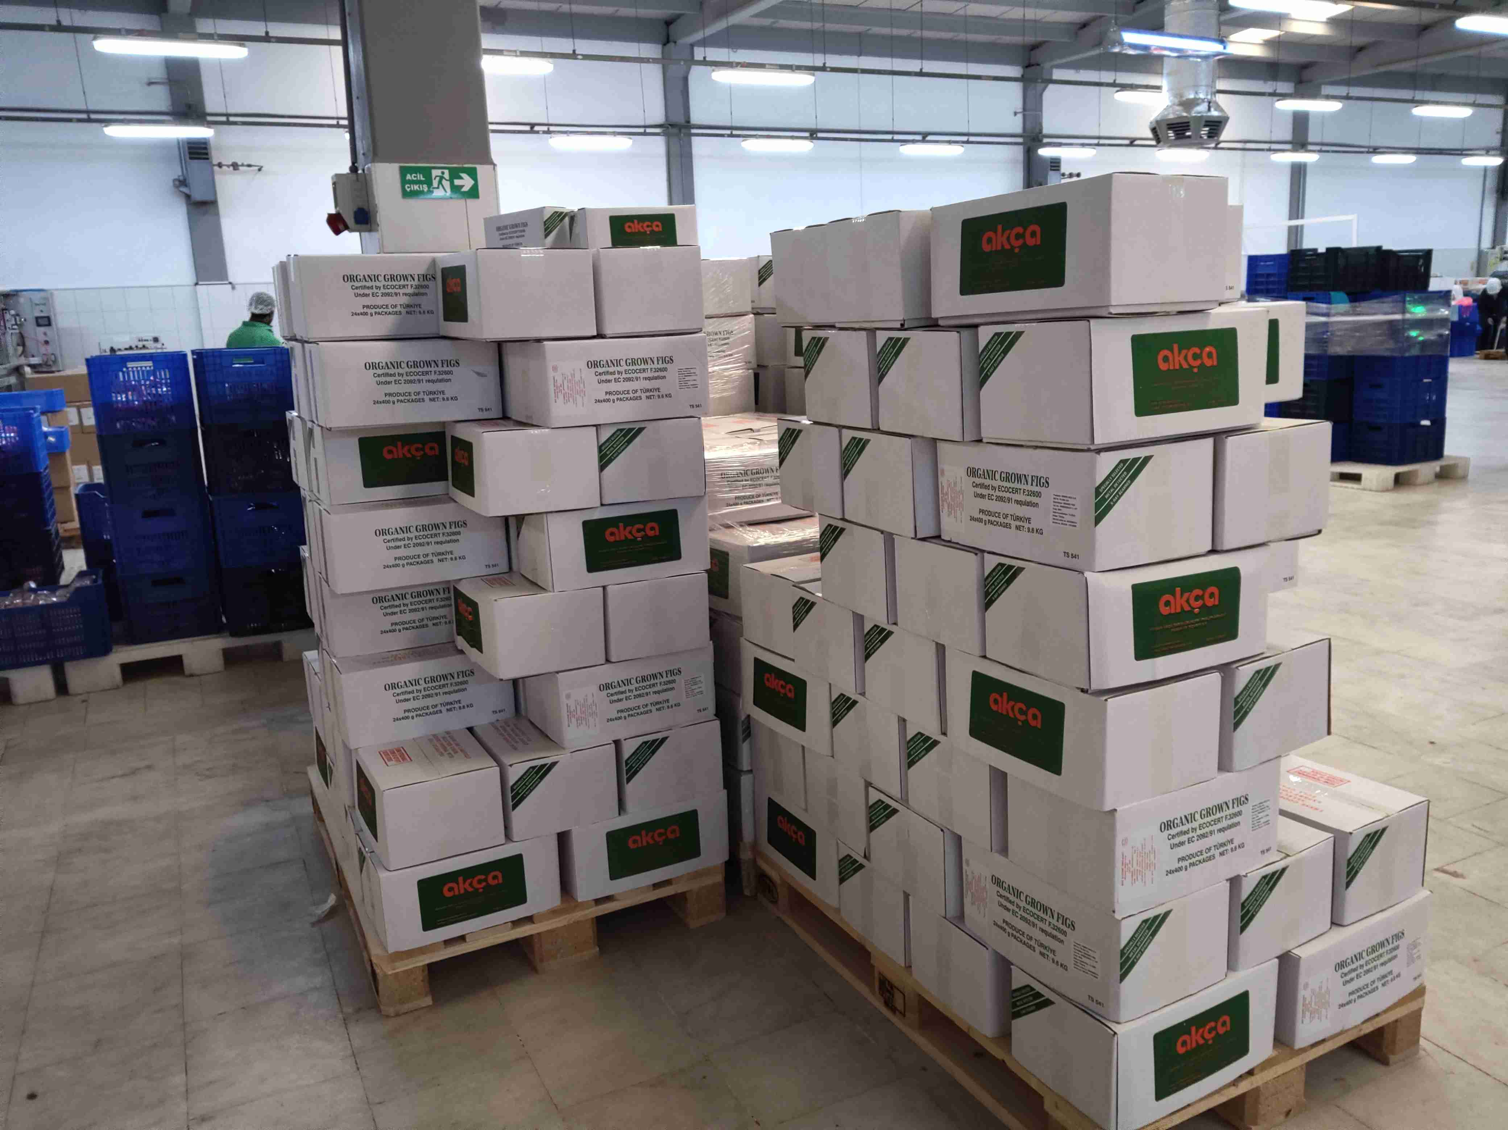
Doraintrade Stamp | 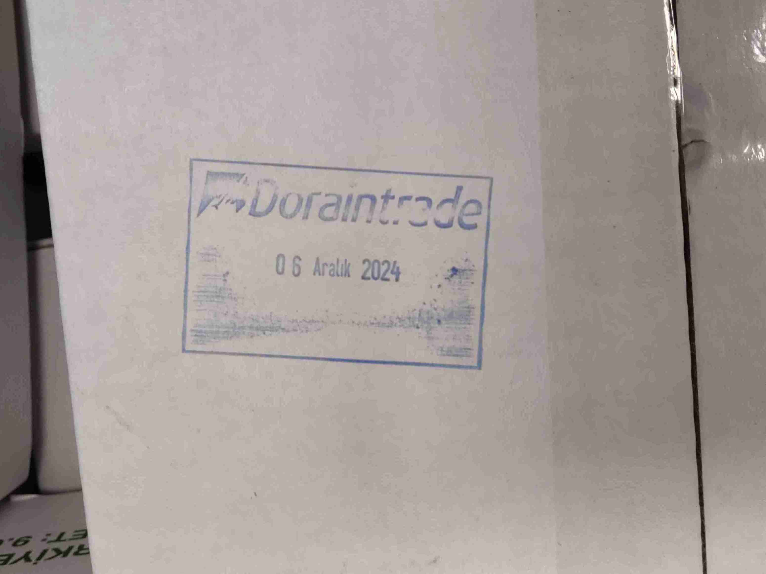
Mix Sample | 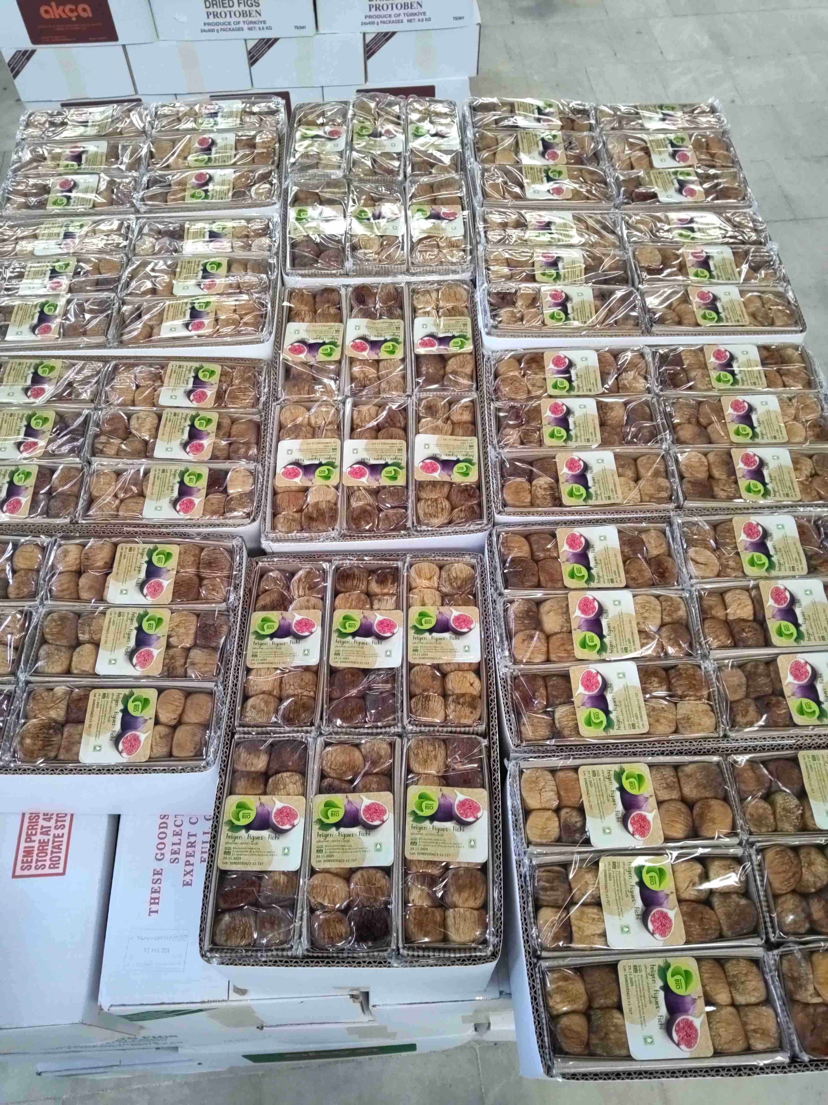
Product | ${image#7}
Physical analysis sample | ${image#8}
Physical Analysis Sample | ${image#9}
insect damage | ${image#10}
Black Mould | ${image#11}
Sour/Fermented | ${image#12}
Sugary/Crystal (inside/outside) | ${image#13}

